Direct formation of Au(III) acetyl, alkoxyl and alkynyl functionalities via halide free tricationic Au(III) precursors

**Robert Corbo, Mohammad Albayer, Neville B. Hall and Jason L. Dutton\***

**Department of Chemistry and Physics, La Trobe Institute for Molecular Sciences**

**La Trobe University**

**Melbourne, Victoria, Australia**

**j.dutton@latrobe.edu.au**

**Abstract**

A novel synthetic approach for the synthesis of gold(III) acetato, alkoxolato and alkynyl complexes was developed *via* the reactivity of gold(III) trications containing the N,N-chelating ligand 2,2’-bipyridine and N,N,N-chelating ligand terpyridine throughdirect reactions with the protic precursors. This protocol avoids the gold(III) chloride bond activation pathway commonly employed to access these functionalities. For example exposure of [LAu(III)L’]OTf3 (L = N,N,N-terpyridine, L’ = 4-DMAP) to RH (R = OCH3, OAc, Ph-≡ ) results in the facile formation of the corresponding functionalised gold(III) complexes [LAu(III)R]OTf2.

**Introduction**

Au(III) coordination compounds containing Au-O functionalities are a topic of current interest.1 In particular Au(µO)Au and Au-O-O-Au linkages have been proposed as key intermediates in heterogeneous Au catalysed CO oxidation2 and electrochemical water splitting at Au electrodes.3 To this end Bochmann utilised the biscyclometallated Au(III)-OH **1** to access a host of isolable Au(III) compounds containing O2- and O2-2 linkages. This included the dinuclear peroxo bridged complex **2**, andmononuclear Au(III) hydroperoxo **3** and alkylperoxo **4** (Scheme 1).4 The conversion of Au(III)-OH **1** to Au–H **5** via phosphine mediated oxygen abstraction was also demonstrated, as well as more recently oxygen abstraction from Au-OMe also by phosphines giving Au-Me.4b



**Scheme 1.** Synthesis of Au(III) oxo and peroxo complexes *via* the biscyclometallated Au(III)-OH **1**.

Recently the characterisation of the first isolable Au(III)-CO and Au(III) olefin complexes were reported.5 The treatment of the bis cyclometallated Au(III) acetate **6** with [Ph3C][PF6] in the presence of a CO atmosphere resulted in the formation of the Au(III)-CO **7** (Scheme 2). The displacement of the acetate ligand from **6** and formation of the Au(III)- complex **8** was achieved through an acetate abstraction from **6** *via* treatment with B(C6F5)3 and then subsequent exposure to C2H4.



**Scheme 2** First example of an isolable Au(III)-CO complex.

The Au(III)-CO and Au(III) π-olefin motifs are purported key intermediates in Au catalysed C-C double and triple bond formation, C-H activation and gold catalysed hydrogenation. Advances in catalytic and stoichiometric transformations at Au(III) centres has been recently reviewed.6 Currently there is an interest in Au(III) complexes as potential d8 organometallic congeners of the well-known Pt(II) class of chemotherapeutics.7-8 A large body of work now exists describing cytotoxicity and antiproliferative mechanisms for a number A(III) compounds, of which Au(III)-OH and Au(III)-OR motifs feature prominently.8-12

Access to Au(III) oxo species generally begins with Au(III)-Cl bond activation via a salt metathesis reaction, which typically involves the use of an alkali or Ag salt and obviously requires the formation of a Au-Cl complex in the first instance.1, 13-15 Recently we reported the synthesis of a new class of Au(III) compound, namely Au(III) trications bound only by monodentate pyridyl ligands (**9R**) (Figure 1).16



**Figure 1.** Pyridine stabilised trications **9R**.

Initial investigations revealed that these compounds allowed for the facile formation of the challenging Au(III)-OH functionality using only water. For example, ligand exchange reactions on **9CN** allowed for the formation of **10,** which upon exposure to water resulted in the formation of the hydroxide **11** in high yield and purity (Scheme 3).17 The simplicity in which the versatile Au(III)-OH functionality was formed led us to envision the potential for further synthetic application utilizing the trications **9R**.



**Scheme 3.** Formation of the Au(III)-OH **11**

Herein we report the direct synthesis of Au(III) alkoxolato, Au(III) acetoxolato and Au(III) alkynyl species under mild conditions avoiding Au-Cl activation and need for other external reagents (e.g. bases) utilizing the Au(III) tricationic scaffold **9R**.

**Results and discussion**

**Silver and base free Alkoxylation Reactions**

Previously, we have reported access to Au(µO)Au and Au(III)-OH species through simple water reactivity. The exposure of **10** towateryielded the corresponding Au(III) hydroxide **11**.17 In this example a single 4-DMAP ligand is displaced by water (generating a Au(III) aquo intermediate) and in turn deprotonates the Au bound water to generate a Au(III)-OH. To investigate whether our system could be further extended to the synthesis of Au(III) compounds of the type Au(III)-OR, the terpyridine containing trication **12** was suspended in dry CH3OH and the resulting slurry was stirred at RT for 3 hr. Although **12** was insoluble in CH3OH a distinct colour change from dark purple to pale yellow was noted after 3 hours stirring. The solids were isolated *via* filtration and 1H NMR analysis of the isolated powder dissolved in CD3CN gave a set of resonances consistent with a single terpyridine moiety and a single resonance at 3.70ppm was taken to indicate the presence of a Au bound methoxide methyl substituent. Single crystals for X-ray diffraction analysis were grown *via* slow vapour diffusion of Et2O into a solution of the isolated solids in CH3OH which revealed the solid-state structure to be the target dication **13** (Scheme 4). To investigate the reactivity of our tricationic framework toward further alkoxylative transformations we turned our focus to the reactivity of **11** under analogous conditions. A single alkoxylation of **11** was desirable as the preservation of a neutral ligand within the Au coordination sphere should allow for further ligand manipulations at the metal centre. Initially **10** was dissolved in dry CH3OH giving a deep red solution. Over a period of two hours a distinct colour change was observed to pale yellow. This colour change was consistent with observations made for the synthesis of the corresponding hydroxide **11** upon exposure of **10** to water, which was taken to indicate potential Au-O bond formation. After a short workup a pale yellow solid was obtained, with 1H NMR analysis of the isolated solids giving a set of signals consistent with a species containing a single 2,2-bipy and single 4-DMAP ligand. A single peak at 2.93ppm with an integration of 3H was also observed which indicated the presence of a Au bound methoxide methyl functionality. Single crystals suitable for X-ray diffraction studies were grown via slow vapour diffusion of Et2O into a CH3OH solution revealing the solid state structure to be **14**. The solid state structure of **13** and **14** are shown in Figures 2 and 3, respectively. The methoxide fragment in **14** appears to exert a slightly stronger –trans effect than related derivatives with 4-DMAP or –OH in that position, with a –trans Au-N bond distance of 2.050(4) Å in **14**, compared with 2.019 Å in **10** and 1.994 Å in **11**. This trend is not reproduced with **13**, although we note it is a lower quality structure with an NDP thermal parameter at N(2). The only intramolecular interactions with the gold centres are long-range interactions in approximately the octahedral axial positions with oxygen atoms from the triflate anions.



**Scheme 4.** Formation of Au(III)-OMe functionality *via* methanol reactivity.

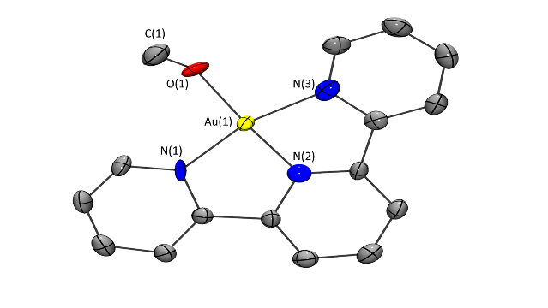

**Figure 2.** Solid-state structure of **13**. Thermal ellipsoids displayed at 50% probability level and hydrogen atoms and triflate counterions omitted. Selected bond distances (Å): Au(1)-N(1) 2.015(9), Au(1)-N(2) 1.870(6), Au(1)-N(3) 2.002(6), Au(1)-O(1) 1.959(6) N(2)-Au(1)-O(1) 175.9(3),

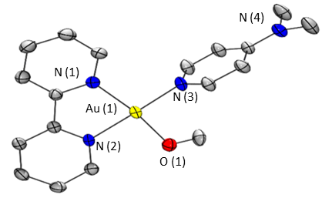

**Figure 3.** Solid-state structure of **14**. Thermal ellipsoids displayed at 50% probability level and hydrogen atoms and triflate counterions omitted. Selected bond distances (Å): Au(1)-N(1) 2.050(4), Au(1)-N(2) 2.022(4), Au(1)-N(3) 2.011(4), Au(1)-O(1) 1.971(4).

Manassero and co-workers reported an equilibrium between the Au(III)(OR)2 **15** and the corresponding Au(III)(OH)2 **16** (Scheme 5).18 Although structural data was not presented for compound **16** the proposed hydrolysis driven interconversion between **15** and **16** was supported by 1H NMR analysis.



**Scheme 5.** Equilibrium between **15** and **16**.

To lend support to this hypothesis we investigated the susceptibility of **13** and **14** toward Au(III)-OH forming hydrolysis. If such an equilibrium exists exposure of **13** or **14** to water should result in the formation of **17** and **11,** respectively (Scheme 6). Spectroscopic data for **17** and **11** have been previously reported making the formation of either species monitorable *via* 1HNMR analysis.17 A solution of **14** in water was stirred for 24 hours. Solvent was removed under reduced pressure giving crude orange solids. 1H NMR spectroscopy analysis of the crude solids dissolved in CD3CN resulted in spectral characteristics clearly diagnostic for the formation of **11**.1H NMR studies of **13** conducted in D2O clearly showed the formation of **17** when left over a period of 48 hr. These results indicate a facile conversion of Au(III)OMe to Au(III)OH functionality *via* exposure to water. Treatment of a pure sample **17** or **11** with dry CH3OH resulted in the reverse process with formation of **13** and **14**, respectively.





**Scheme 6.** Au(III) methoxide/hydroxide equilibrium.

**Au carboxylate synthesis**

Currently there are only a handful of crystallographically characterised organometallic Au(III) acetate complexes,15, 19-25 including a single bridging example26 and one incorporating a non-cyclometallated Au centre.27 The Au(III) acetate **6** was used to great effect in the isolation and characterisation of A(III) carbonyl **7** and Au(III) π complex **8**. Access to **7** and **8** is gained *via* acetate abstraction and either CO or C2H4 coordination.5 The group of Nevado has developed a gold catalysed aryl-aryl heterocoupling which is reported to proceed *via* boronic ester transmetallation, C-H activation and then C-C bond forming reductive elimination (Scheme 7).27 The transmetallation is proposed to occur at Au(I) precursor **18** and C-H activation via electrophilic aromatic substitution at a bis acetato Au(III) intermediate, which is nicely supported by the isolation and characterisation of the rare non-cyclometallated Au(III) bis acetato species in compound **19**.



**Scheme 7.** Formation of Au(III) Ar-Ar coupling intermediate **19**.

Owing to the limited representation of Au(III) acetato complexes in the literature we hypothesized that our tricationic Au(III) scaffold, based on the previously observed oxoacid reactivity of the trications, should give access to Au acetato complexes simply by exposure to organic acids.

Compound **10** was selected for the initial study as the potential formation of **20** could be easily monitored by 1HNMR as the synthesis of **20** has been previously reported via a Au-Cl activation pathway using AgOAc.18 In the presence of water **20** was reported to readily undergo conversion to the bis hydroxide **16**.18 To avoid undesirable hydrolysis reactions all our studies were conducted in HOAc distilled from P2O5. Compound **10** was stirred in dry HOAc for 3 days under an atmosphere of nitrogen. The poor solubility of **10** in HOAc led to the initial formation of a red slurry, however, stirring over a three-day period gave a colourless solution, of which the addition of Et2O yielded an off white precipitate. Proton NMR analysis of the isolated solids dissolved in (CD3)2CO gave spectral characteristic consistent with previous reports for the synthesis of the monocation **20** as a PF6 salt (Scheme 8).18 In our hands crystals of sufficient quality for X-ray diffraction analysis were unattainable. Compound **12,** upon exposure to CH3OH or water, has been shown to give ready access to the isolable and characterisable Au(III)-OMe **13** and Au(III)-OH **17**, and was therefore investigated for potential Au(III) acetato forming reactivity. A slurry of **12** in dry HOAc was stirred for 24 hours. After a quick work-up the crude solids were dissolved in CD3CN and 1H NMR analysis revealed resonances consistent with a single terpy containing moiety and a sharp singlet was also observed at 2.38ppm indicating the presence of a MeCOO methyl proton environment. Crystals suitable for X-ray diffraction studies were grown *via* slow vapour diffusion of Et2O into a solution of the isolated solids in glacial acetic acid and confirmed the solid state structure of the isolated solids to be that of compound **21** (Figure 4). Proton NMR analysis conducted on a sample of **21** left to stir in H2O for 48 hours confirmed the formation of compound **17** as reported byPitteri.28

The Au-O bond in **21** is slightly longer than the Au-O bonds in the methoxide complexes with a distance of 1.992(4) Å. The acetate ligand gives a less strong –trans effect than having 4-DMAP in that the Au(1)-N(2) bond in **21** is 1.963(4) Å compared to 1.935 Å in **10**. While subtle, this could imply that acetate is a weaker ligand than 4-DMAP and the driving force for the reaction is the acidity of acetic acid and consequent protonation of the released 4-DMAP ligand. This is also consistent with the removal of both 4-DMAP units from **11**, while methanol is only able to displace one 4-DMAP in the reaction generating **14**.

**Scheme 8.** Acetic acid protocol for the formation of Au(III) acetate complexes

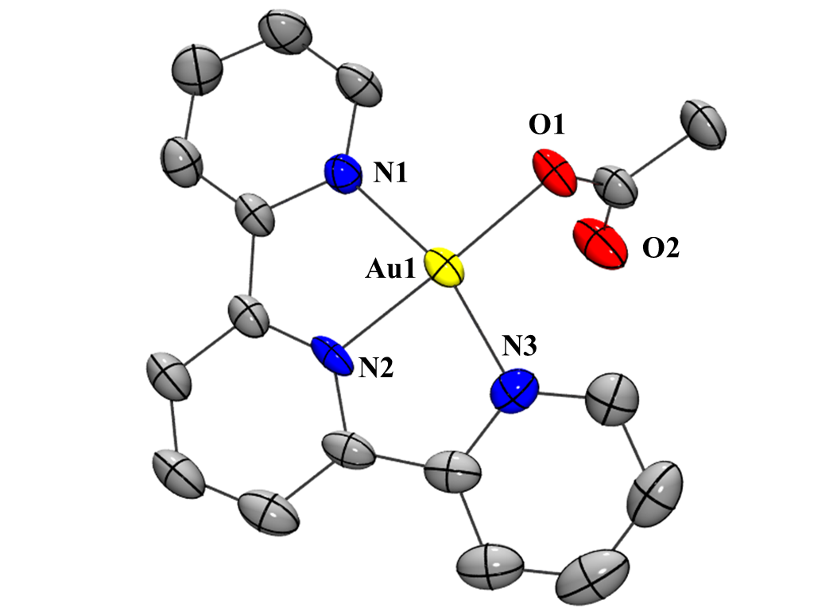

**Figure 4.** Solid-state structure of **21**. Thermal ellipsoids displayed at 50% probability level and hydrogen atoms and triflate counterions omitted. Selected bond distances (Å): Au(1)-N(2) 1.963(4), Au(1)-N(1) 2.019(4), Au(1)-N(3) 2.020(4), Au(1)-O(1) 1.992(4).

**Alkyne C-H activation**

Another important functionalisation utilized within the area of organo-Au(III) chemistry is Au(III) alkynyl formation. The syntheses of Au(III) acetylides typically require the presence of a non-nucleophilic base and proceed via a salt metathesis involving either CuX (X = Br, Cl) or an alkyl Li reagent from an Au(III)-Cl precursor. A rare deviation from this comes from the report by Bochmann where Au(III) alkyne formation is achieved via C-H activation at a cyclometallated Au(III) hydroxide.1 Au(III) acetylides are key intermediates in catalytic aryl alkynylations and have been shown to display desirable photophysical properties. 29-31 A solution of **12** in CHCl3 was stirred with 1 equivalent of phenylacetylene for approximately 12 hours. The solvent was removed in vacuo giving a crude orange powder. 1HNMR analysis of the crude solids dissolved in CD3CN revealed the presence of protonated 4-DMAP as compared with a independently synthesised sample, and a set of resonances consistent with a single terpyridine containing species. Crystals suitable for X-ray diffraction analysis were grown via slow vapour diffusion of Et2O into a solution of the isolated product in CH3CN and revealed the solid state structure to be that of **22** (Figure5). Au(III) acetylides have been shown to be highly luminescent. Preliminary studies showed compound **22** to be non-emissive at wavelengths 265nm and 365nm, which is likely due to (1) the absence of a strong sigma donating ligand within the supporting ligand system to facilitate the necessary destabilisation of the low lying d-d transitions, and (2) the possibility of geometric destorsions due to the absence of C-Au bonds within the terpyridine ligand system.32,33



**Scheme 9.** Synthesis of the terminal Au(III) acetylide *via* treatment of trication **12** with phenylacetylene.

The NDP nature of atom N(2) makes discussion of the potential –trans effect of the acetylene fragment to imprecise to be useful.

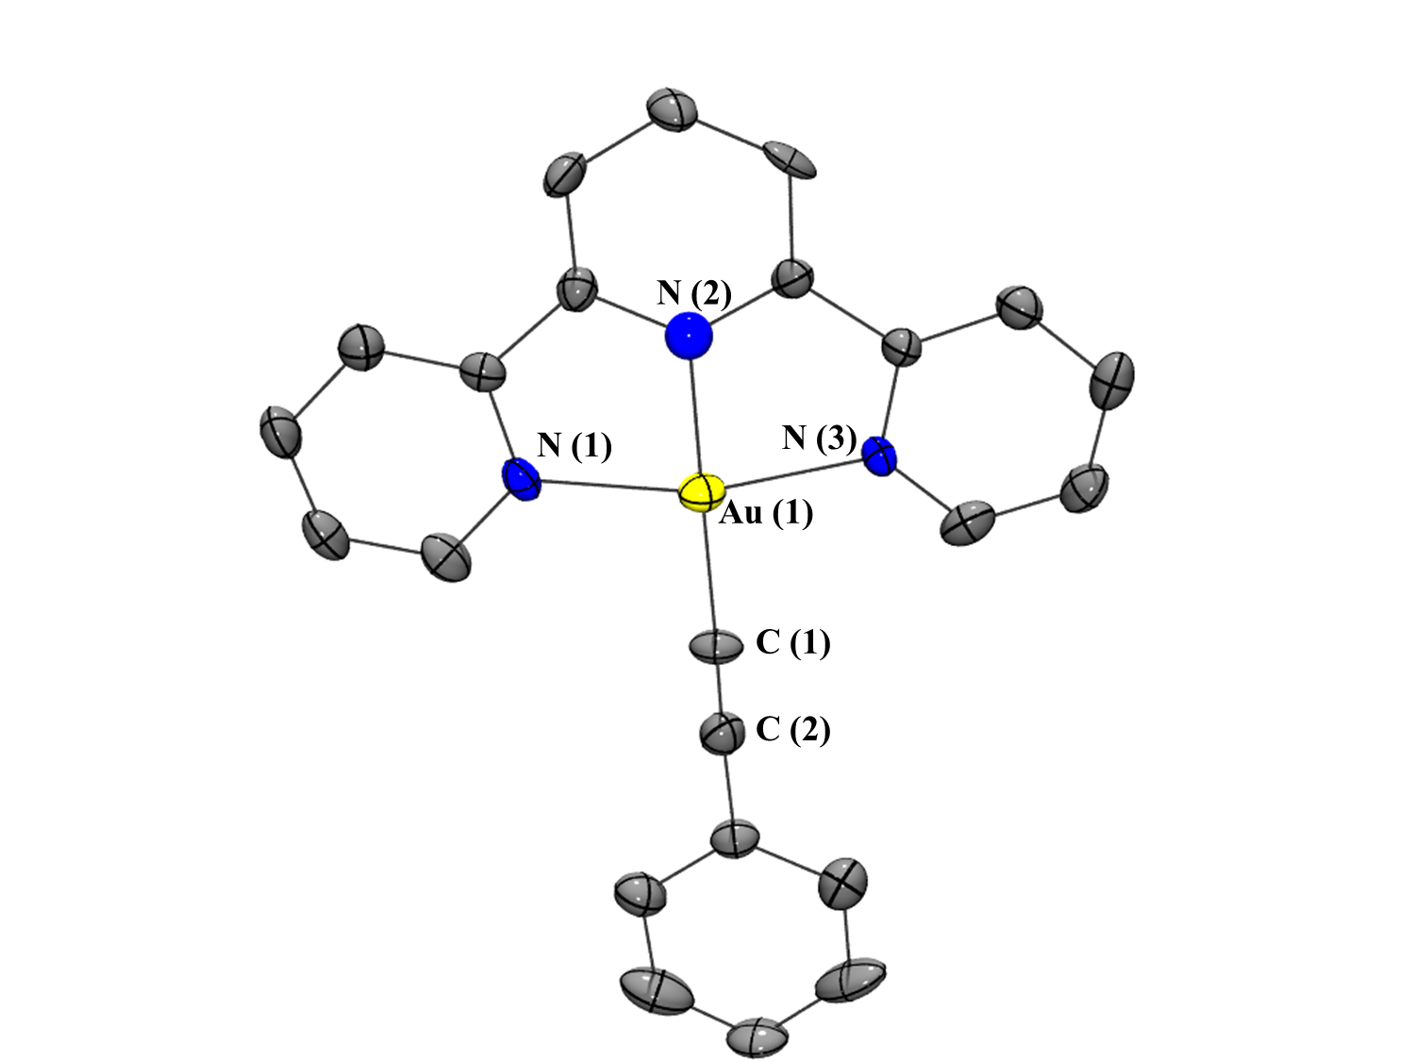

**Figure 5** Solid-state structure of **22**. Thermal ellipsoids displayed at 50% probability level and hydrogen atoms and triflate counterions omitted. Selected bond distances (Å): Au(1)-C(1) 1.99(1), Au(1)-N(2) 1.960(8), Au(1)-N(1) 2.04(1), Au(1)-N(3) 2.05(1).

**Conclusion**

We have shown that the trications **10** and **12** are effective reagents for the facile generation of Au(III) alkoxide and Au(III) acetato complexes. The Au(III) methoxide **13** and **14**, and the Au(III) acetate complexes **20** and **21** are prepared by either the simple addition of CH3OH or acetic acid, respectively, which in both examples avoids the traditional Au(III)-Cl activation step usually employed in these systems. Compound **22** represents the first example of a terminal Au(III) acetato complex supported only by neutral ligands. The reactivity of **12** was also shown to extend to alkyne C-H activation, which is not in of itself novel, however, the absence of a Au-Cl activation protocol and no requirement for use of additional external reagents in these reactions is rare. The fact that these transformations proceed with such ease, in good yields and under mild conditions demonstrates the versatility of these novel tricationic Au(III) scaffolds.

Acknowledgements

We thank La Trobe University and The La Trobe Institute of Molecular Sciences for their generous funding of this project. J. Dutton thanks the ARC (FT17010007) for a Future Fellowship to support work on the project.

**Experimental Section**

Solvents used in air sensitive manipulations were obtained from Caledon Laboratories and dried using an Innovative Technologies Solvent Purification System with dual columns packed with solvent appropriate drying agents. The dried solvents were stored under an N2 atmosphere over 3 Å molecular sieves in the glovebox. MeOH was dried with 3 Å molecular sieves and acetic acid was distilled from P2O5. Solvents for NMR spectroscopy (CDCl3, CD3CN) were purchased from Cambridge Isotope Laboratories and dried by stirring for three days over CaH2, distilled prior to use, and stored in the glovebox over 3 Å molecular sieves. Compounds **10** and **12** were synthesized as previously reported.16, 17 All other reagents were used as received.

Single crystals were selected under n-paratone oil, mounted on nylon loops and placed into a cold stream (172 K) of N2 on an Oxford CCD diffractometer using Mo or Cu Kα radiation. Structure solution and refinement were performed using the SHELXTL suite of software.

**Synthesis of compound 13**

A solution of **12** (0.200 g, 0.200 mmol; CH3OH 30 mL) was stirred at RT in the absence of visible light until a colour change from purple to pale yellow was observed (approximately 3 hours). The reaction mixture was concentrated and upon addition of Et2O yielded **13** as a pale yellow solid.

**Yield 0.**148 g, 86%,

**1H NMR** (CD3CN,  ppm) 8.89 (dd, 2H, *J* = 7.3, 1.5 Hz), 8.75 (m,1H), 8.67 (td, 2H, *J* = 10, 1.8 Hz), 8.59 (t, 4H, *J* = 10 Hz), 8.17 (dd, 2H*, J* = 7.3, 2 Hz) 3.70 (s, 3H, AuOCH3)

**13C{1H}d NMR** (CD3CN,  ppm) 159.0, 153.4, 150.8, 148.7, 131.9, 129.7, 128.3, 63.3

**Synthesis of compound 14**

A solution of **10** (0.200 g, 0.191mmol; CH3OH 80 mL) was stirred at RT for approximately two hours until a colour change from bright red to pale orange was observed. The reaction mixture was then concentrated under reduced pressure and the addition of Et2O yielded **14** as a pale orange solid.

**Yield** 0.138 g, 90%,

**1H NMR** (CD3CN,  ppm) 9.07 (d, 1H, *J* = 4.8Hz, bipy), 8.6 (m, 4H, bipy), 8.30 (d, 2H, *J* = 5.9 Hz, *o*-H of 4-DMAP), 8.14 (m, 2H, bipy), 6.98 (d, 2H, *J* = 5.9 Hz, *m*-H of 4-DMAP), 3.23 (s, 6H, N(Me)2), 2.93 (s, 3H, AuOCH3)

**13C{1H} NMR** (CD3CN,  ppm) 157.8, 156.4, 155.5, 149.7, 147.5, 130.1, 131.4, 127.6, 123.7, 121.1, 111.7, 63.6, 40.8

**Elemental analysis, calculated (found)**: C 29.86 (29.48), H 2.63 (2.70), N 6.96 (6.96)

**Synthesis of compound 20**

A solution of **11** (90 mg, 0.086 mmol; HOAc 10 mL) was stirred at room temperature for 3 days in the absence of visible light. The addition of Et2O resulted in the formation of an off white precipitate. Spectral and physical data were consistent with previous reports for the synthesis of **21**.21

**Synthesis of compound 21**

A solution of **12** (0.190 g, 0.190 mmol; HOAc 10 mL) was stirred at room temperature for 24 hours in the absence of visible light. A beige precipitate was isolated *via* centrifugation and washed with Et2O (2x 2 mL) to yield **21** as an off white solid.

**Yield** 0.095g, 64%,

**1H NMR** (CD3CN,  ppm) 8.79 (t, 1H, *J* = *5*.5Hz, terpy), 8.72 (d, 2H, *J* = 5.9 Hz, terpy), 8.67 (td, 2H, *J* = 8.0, 1.4 Hz, terpy)8.55 (m, 4H, terpy), 2.38 (s, 3H, AuOAc)

**13C{1H} NMR** (CD3CN,  ppm) 176.8, 159.4, 154.8, 152.4, 149.5, 148.5, 132.0, 130.0, 128.5, 22.1

**Elemental analysis, calculated (found):** C 28.98 (28.98), H 1.79 (1.84), N 5.34 (5.56)

**Synthesis of compound 22**

To a solution of **12** (0.237 g, 0.237 mmol; CHCl3 10 mL) was added phenylacetylene (0.025mL, 0.237mmol) and the mixture was stirred at RT in the absence of visible light for 24 hours. Solids were isolated via centrifugation and washed with hot CHCl3 (3 x 5mL) and cold CH3CN (3 mL). Volatiles were removed *in vacuo* yielding **22** as a bright yellow solid.

**Yield** 0.122g, 84%,

**1H NMR** (CD3CN,  ppm) 9.38 (d, 2H, *J* = 5.4 Hz, terpy), 8.79 (dd, 1H, *J* = 8.3, 9.0), 8.68 (td, 2H, *J* = 1, 7.6), 8.60 (m, 4H), 8.09 (m, 2H), 7.74 (m, 2H), 7.50 (m, 3H)

**13C{1H} NMR** (CD3CN,  ppm) 160.6, 156.3, 154.2, 148.9, 148.1, 132.9, 132.8, 131.1, 130.2, 130.1, 128.4, 123.7, 95.0, 87.3.

**FT-IR** (KBr, ν, cm-1) 2165

**Elemental analysis, calculated (found):** C 36.20 (35.57), H 1.94 (1.90), N 5.07 (4.84)

**Exposure of 13 to water**

Compound **13** was dissolved in 10 mL of distilled H2O and stirred in the absence of viable light for approximate 24 hours. Spectral characteristics consistent with previous reports confirmed the formation of **17** as the major product.28

**Exposure of 14 to water**

Compound **14** was dissolved in 10 mL of distilled water and stirred in the absence of viable light for approximate 24 hours. Water was removed *in vacuo* to give crude orange solids. Spectral characteristics consistent with previous reports confirmed the formation of **11** as the major product.16

**Exposure of 21 to water**

Compound **21** was dissolved in 10 mL of distilled water and stirred in the absence of viable light for approximate 24 hours. Water was removed *in vacuo* to give crude beige solids. Spectral data were consistent with the formation of **17** as the major product.28

**References**

1. Roşca, D.; Smith, D. A.; Bochmann, M., *Chem. Commun.* **2012**, *48*, 7247-7249.

2. Yang, M.; Li, S.; Wang, Y.; Herron, J. A.; Xu, Y.; Allard, L. F.; Lee, S.; Huang, J.; Mavrikakis, M.; Flytzani-Stephanopoulos, M., *Science* **2014**, *346*, 1498-1501.

3. Diaz-Morales, O.; Calle-Vallejo, F.; de Munck, C.; Koper, M. T. M., *Chem. Sci.* **2013,** *4*, 2334-2343.

4. a) Roşca, D.; Wright, J. A.; Hughes, D. L.; Bochmann, M., *Nat. Comm.* **2013,** *4*, 2167. b) Chambrier, I.; Roşca, D.; Fernandex-Cestau, J.; Hughes, D. L.; Budzelaar, P. H. M.; Bochmann, M. *Organometallics*, **2017**, *36*, 1358-1364.

5. Roşca, D.; Fernandez-Cestau, J.; Morris, J.; Wright, J. A.; Bochmann, M., *Science Advances* **2015,** *1* e1500761.

6. Joost, M.; Amgoune, A.; Bourissou, D., *Angew. Chem. Int. Ed.* **2015,** *54*, 15022 –15045.

7. Zou, T.; Lum, C. T.; Lok, C.-N.; Zhang, J.-J.; Che, C.-M., *Chem. Soc. Rev.,* **2015**, 44, 8786-8801

8. Gabbiani, C.; Massai, L.; Scaletti, F.; Michelucci, E.; Maiore, L.; Cinellu, M. A.; Messori, L., *J. Biol. Inorg. Chem.* **2012,** *17*, 1293-1302.

9. Marcon, G.; Carotti, S.; Coronnello, M.; Messori, L.; Mini, E.; Orioli, P.; Mazzei, T.; Cinellu, M. A.; Minghetti, G., *J. Med. Chem.* **2002,** *45*, 1672-1677.

10. Coronnello, M.; Mini, E.; Caciagli, B.; Cinellu, M. A.; Bindoli, A.; Gabbiani, C.; Messori, L., *J. Med. Chem.* **2005,** *48*, 6761–6765.

11. Casini, A.; Kelter, G.; Gabbiani, C.; Cinellu, M. A.; Minghetti, G.; Fregona, D.; Fiebig, H.; Messori, L., *J. Biol. Inorg Chem.* **2009,** *14*, 1139-1149.

12. Messori, L.; Marcon, G.; Cinellu, M. A.; Coronnello, M.; Mini, E.; Gabbiani, C.; Orioli, P., *Biorg. Med. Chem.* **2004,** *12*, 6039-6043.

13. Cinellu, M. A.; Minghetti, G.; Pinna, M. V.; Stoccoro, S.; Zucca, A.; Manassero, M., *Eur. J. Inorg. Chem.* **2003,** *2003*, 2304-2310.

14. Cinellu, M. A.; Minghetti, G.; Pinna M. V.; Stoccoro, S.; Zucca, A.; Manassero, M.; Sansoni, M., *J. Chem. Soc., Dalton Trans.* **1998,** 1735-1742.

15. Cocco, F.; Cinellu, M. A.; Minghetti, G.; Zucca, A.; Stoccoro, S.; Maiore, L.; Manassero, M., *Organometallics* **2010,** *29*, 1064-1066.

16. Corbo, R.; Pell, T. P.; Stringer, B. D.; Hogan, C. F.; Wilson, D. J. D.; Barnard, P. J.; Dutton, J. L., *J. Am. Chem. Soc.* **2014,** *136*, 12415-12421.

17. Corbo, R.; Ryan, G. F.; Haghighatbin, M. A.; Hogan, C. F.; Wilson, D. J. D.; Hulett, M. D.; Barnard, P. J.; Dutton, J. L., *Inorg. Chem.* **2016,** *55*, 2830-2839.

18. Cinellu, M. A.; Minghetti, G.; Pinna, M. V.; Stoccoro, S.; Zucca, A.; Manassero, M., *J. Chem. Soc., Dalton Trans.* **2000,** 1261-1265.

19. Mack, J.; Ortner, K.; Abram, U.; Parish, R. V *Z. Anorg. Allg. Chem.* **1997,** *623*, 873-879.

20. Parish, R. V.; Wright, J. P.; Pritchard, R. G., *J. Organomet. Chem.* **2000,** *596*, 165-176.

21. Fan, D.; Yang, C.-T.; Ranford, J. D.; Lee, P. F.; Vittal, J. J., *Dalton Trans.* **2003,** 2680-2685.

22. Collado, A.; Bohnenberger, J.; Oliva-Madrid, M.-J.; Nun, P.; Cordes, D. B.; Slawin, A. M. Z.; Nolan, S. P., *Eur. J. Inorg. Chem.* **2016,** *2016*, 4111-4122.

23. Venugopal, A.; Shaw, A. P.; Törnroos, K. W.; Heyn, R. H.; Tilset, M., *Organometallics* **2011,** *30*, 3250-3253.

24. Smith, D. A.; Roşca, D.; Bochmann, M., *Organometallics* **2012,** *31*, 5998-6000.

25. Akhmadullina, N. S.; Borissova, A. O.; Garbuzova, I. A.; Retivov, V. M.; Sandu, R. A.; Kargin, Y. F.; Shishilov, O. N., *Z. Anorg. Allg. Chem.* **2013,** *639*, 392-397.

26. Bessonov, A. A.; Morozova, N. B.; Gelfond, N. V.; Semyannikov, P. P.; Trubin, S. V.; Shevtsov, Y. V.; Shubin, Y. V.; Igumenov, I. K., *Surf. Coat. Technol.* **2007,** *201*, 9099-9103.

27. Hofer, M.; Genoux, A.; Kumar, R.; Nevado, C., *Angew. Chem. Int. Ed.* **2017,** *56*, 1021-1025.

28. Pitteri, B.; Marangoni, G.; Visentin, F.; Bobbo, T.; Bertolasi, V.; Gilli, P., *J. Chem. Soc. Dalton Trans.* **1999**, 677-682.

29. To, W.-P; Chan, K. T.; Tong, G. S. M.; Ma, C.; Kwok, W.; Guan, X.; Low, K.; Che, C.-M., *Angew. Chem. Int. Ed.* **2013,** *52*, 6648-6652.

30. Cheng, G.; Chan, K. T.; To, W.-P.; Che, C.-M., *Adv. Mater.* **2014,** *26*, 2540-2546.

31. Chen, Z.; Wong, K. M.-C.; Au, V. K.-M.; Zu, Y.; Yam, V. W.-W., *Chem. Commun.* **2009,** 791-793.

32. Yam, V. W.-W.; Choi, S. W.-K.; Lai, T.-F.; Lee, W.-K., *J. Chem. Soc., Dalton Trans.* **1993,** 1001-1002.

33. Wong, K. M.-C.; Hung, L.-L.; Lam, W. H.; Zhu, N.; Yam, V. W.-W., *J. Am. Chem. Soc.* **2007,** *129*, 4350-4365.

Table of contents figure and synopsis



Au(III) methoxides, acetates and acetylides can be formed in one pot with no need for addition of a base via direct reaction with pyridine ligated Au(III) trications.