Supporting information for

PhI(OTf)2 Does Not Exist (Yet)

Tania, Sevan D. Houston Lachlan Sharp-Bucknall, Tiffany B. Poynder, Mohammad Albayer, Jason L. Dutton*

Department of Chemistry and Physics, La Trobe University, Melbourne, Victoria, Australia

J.dutton@latrobe.edu.au

EXPERIMENTAL SECTION:

EXPERIMENTAL DETAILS

Solvents used were dried using an Innovative Technologies Solvent Purification System. The dried solvents were stored under a N2 atmosphere over 3 Å molecular sieves in the glovebox. Solvents for NMR spectroscopy were purchased from Cambridge Isotope Laboratories and dried by stirring for three days over CaH2, distilled prior to use, and stored in the glovebox over 3 Å molecular sieves. All other reagents were purchased from Sigma Aldrich and used as received. All reactions were performed within a N2 filledglove box unless otherwise stated. All glassware was dried in an oven at 110oC overnight and transferred to the glovebox port or Schlenk line where it was subject to three vacuum cycles over 30 minutes prior to use. NMR details for the reaction of PhI(OAc)2 with 2 TMS-OTf stopping at PhI(OAc)(OTf) are previously reported.1

**Synthesis of PhI=O**

Following the procedure of Roelfes *et al.*:2 in a fume hood, a 50 mL beaker was charged with PhI(OAc)2 (2.2 g, 6.83 mmol). NaOH (3M, 10 mL, 30 mmol) was added dropwise (10 min) with vigorous stirring. After 1.5 h, a thick yellow paste had formed. Water (15 mL) was added then the mixture was filtered. The yellow paste was returned to the beaker, sonicated with water (15 mL), then filtered again and washed with water (15 mL). After drying under high vacuum (16 h), the yellow powder was sonicated with chloroform (15 mL), then filtered for a final time and washed with additional chloroform (15 mL) to give the title compound as a white powder (1.07 g, 78%).

**Reaction of PhIO and TMS-OTF**

To a vigorously stirring suspension of PhIO (10 mg, 0.045 mmol) in CD2Cl2 (500µL) was added TMS-OTf(16 µL, 0.091 mmol) to immediately receive a clear solution. The solution was stirred for 15 minutes before being taken for 1H-NMR analysis.



Figure S1. 1H-NMR of reaction between PhIO and TMS-OTf in CD2Cl2 after 15 minutes.



Figure S2. 1H-NMR of reaction between PhIO and TMS-OTf in CD2Cl2 after 16 hours.



Figure S3. 1H-NMR of reactionbetween PhIO and TMS-OTf in CD2Cl2 at 15 minutes (blue) and 16 hours (green) stacked against PhIO (maroon).

Figure S4. Positive ion mode mass spectrum of the reaction between PhIO and 2 TMS-OTf

**Reaction of PhIO and triflic anhydride in CD2Cl2**

To a suspension of PhIO (16 mg, 0.073 mmol) in 2 mL CD2Cl2 was added triflic anhydride (12 µL, 0.072 mmol). The resulting suspension was stirred for 1 hour at room temperature to receive a yellow solution before an aliquot was removed for *in-*situ 1H and 19F-NMR analysis.

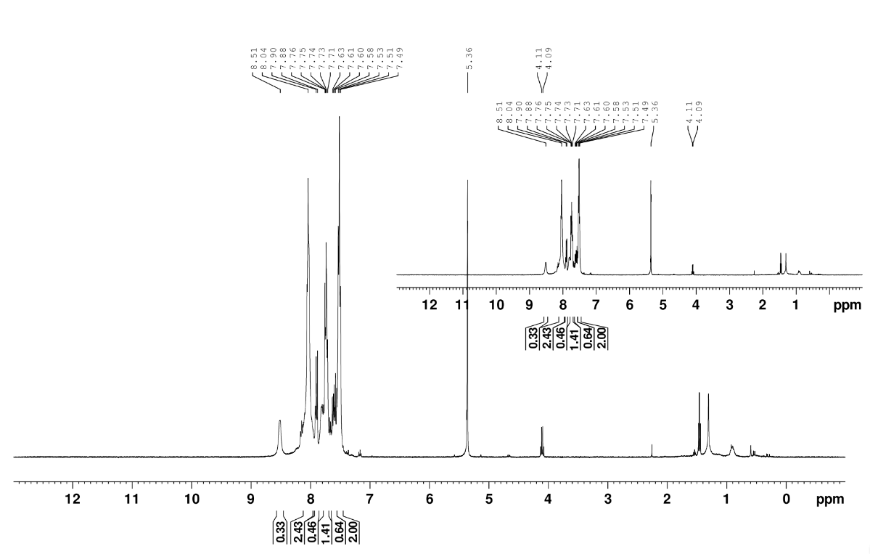

Figure S5. 1H-NMR of reaction between PhIO and triflic anhydride in CD2Cl2.

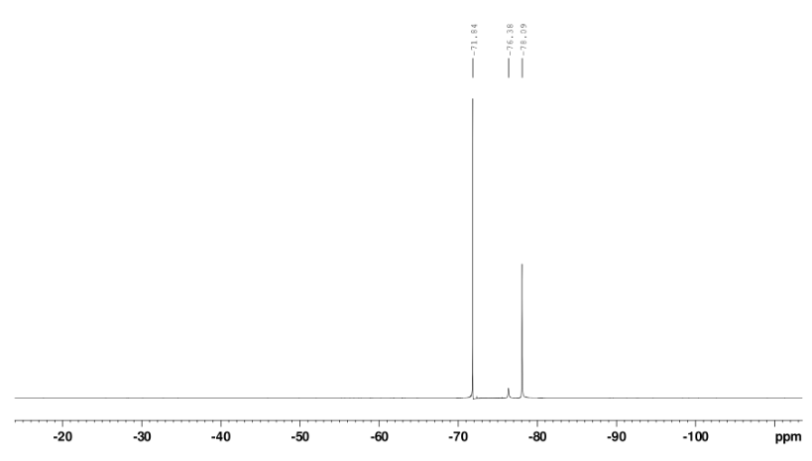

Figure S6. 19F-NMR of reaction between PhIO and triflic anhydride in CD2Cl2.

**Reaction of PhIO and triflic acid**

In a fume hood, triflic acid (11 mg, 0.073 mmol) was weighed into an RBF under an inert nitrogen atmosphere, then dissolved in anhydrous CD2Cl2 (500 µL). Iodosobenzene (8 mg, 0.037 mmol) was weighed into a separate flask, placed under high vacuum for 5 min, then backflushed with nitrogen. The triflic acid solution was transferred by needle and syringe to the iodosbenzene, and the resulting mixture was left to stir until homogenous (5 min), then transferred by needle and syringe to a sealed NMR tube under a nitrogen atmosphere. 1H- and 19F-NMR were recorded at 30 min, then again at 17 h



Figure S7. 1H-NMR of reaction between PhIO and triflic acid after 30 minutes.



Figure S8. 19F-NMR of reaction between PhIO and triflic acid after 30 minutes.



Figure S9. 1H-NMR of reaction between PhIO and triflic acid after 17 hours.



Figure S10. 19F-NMR of reaction between PhIO and triflic acid after 17 hours.

**PhI(OAc)(OTf)**

In a nitrogen filled glovebox, PhI(OAc)2 (330 mg, 1.02 mmol, 1 eq.) was dissolved in CH2Cl2 (4 mL). TMS-OTf (228 mg, 1.02 mmol, 1 eq.) was added in one portion and the mixture was stirred for 1 h. Volatiles were removed in vacuo until approximately 0.5 mL of a yellow oil remained. The oil was treated with hexanes (1 mL) and stirred vigorously for 1 min. The biphasic mixture was left to settle, and the hexanes portion was decanted off. This was repeated 5 times. The waxy residue was treated with hexanes (1 mL) and volatiles were removed in vacuo. The addition of hexanes and subsequent removal was repeated thrice to afford the title compound as a white solid (282 mg, 67%).

**Reaction of PhI(OAc)(OTf) with one equivalent of TMS-OTf**

In a nitrogen filled glovebox, PhI(OAc)(OTf) (21.5 mg, 0.0522 mmol, 1 eq.) was dissolved in CD3CN (0.6 mL). TMS-OTf (11.6 mg, 0.0522 mmol, 1 eq.) was added in one portion and the mixture was stirred for 15 min before being taken for 1H-NMR analysis.

**Reaction of PhI(OAc)(OTf) with four equivalents of TMS-OTf**

In a nitrogen filled glovebox, PhI(OAc)(OTf) (21.5 mg, 0.0522 mmol, 1 eq.) was dissolved in CD3CN (0.6 mL). TMS-OTf (46.4 mg, 0.209 mmol, 4 eq.) was added in one portion and the mixture was stirred for 15 before being taken for 1H-NMR analysis.

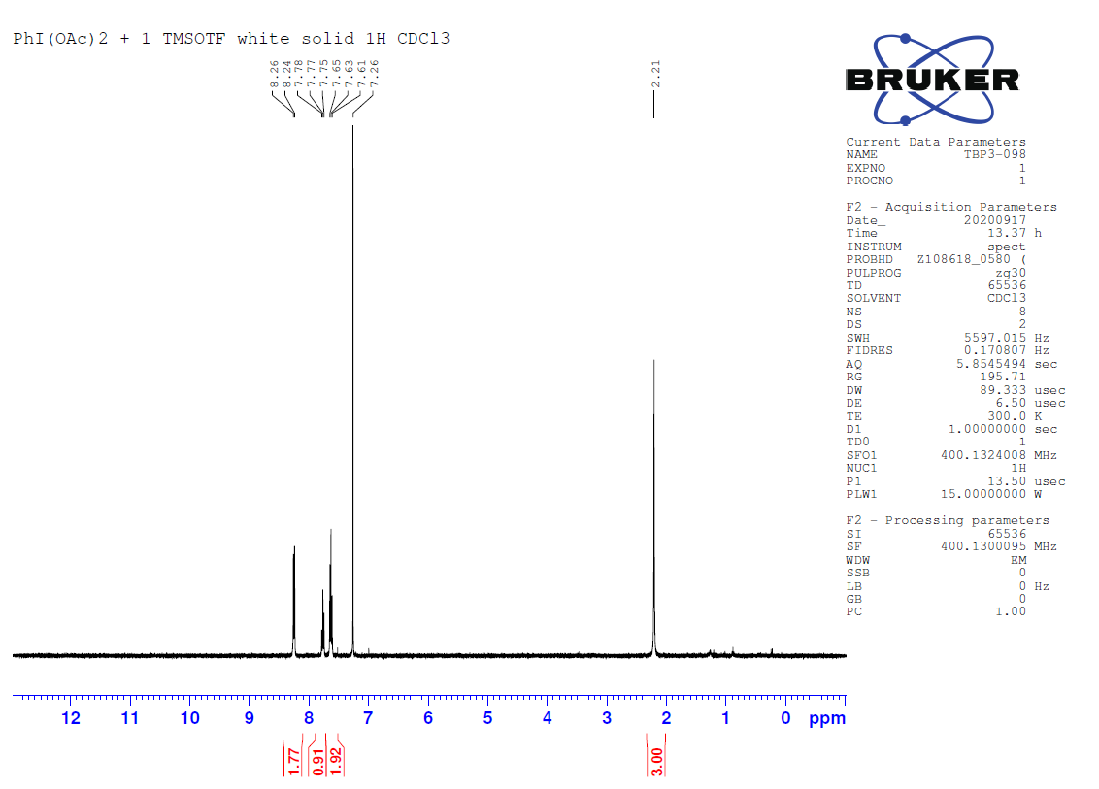

Figure S11. 1H-NMR of PhI(OAc)(OTf) in CDCl3.

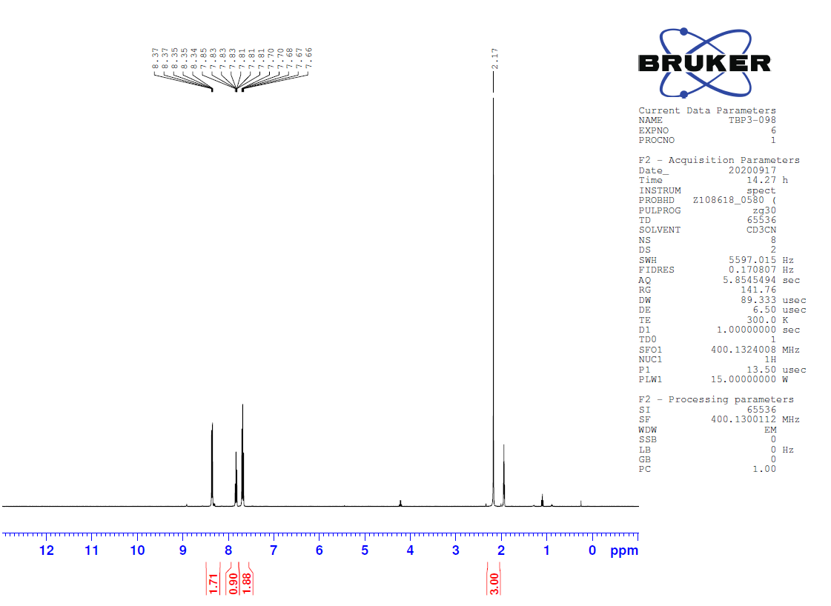

Figure S12. 1H-NMR of PhI(OAc)(OTf) in CD3CN.

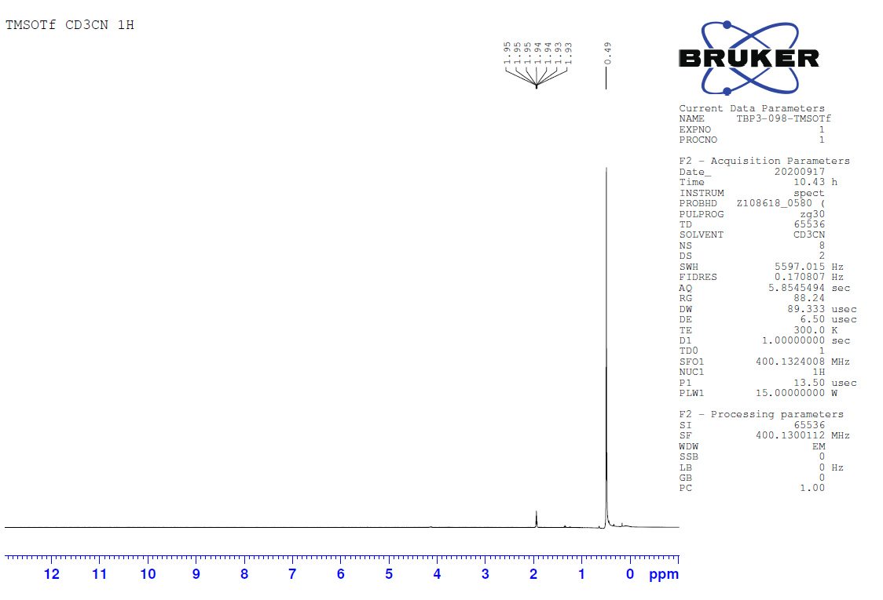

Figure S13. 1H-NMR of TMS-OTf in CD3CN.

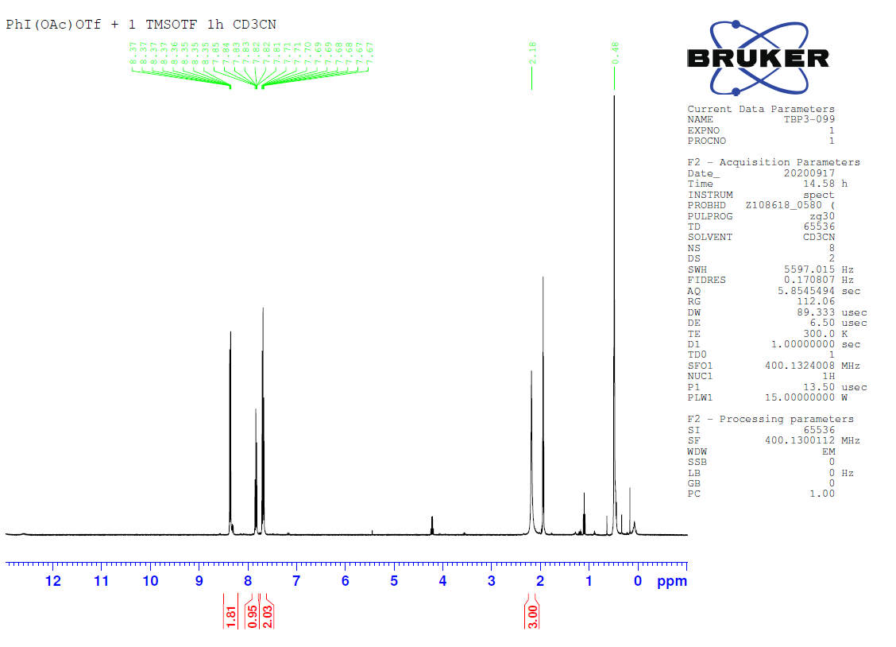

Figure S14. 1H-NMR of PhI(OAc)(OTf) + 1 TMS-OTf in CD3CN.

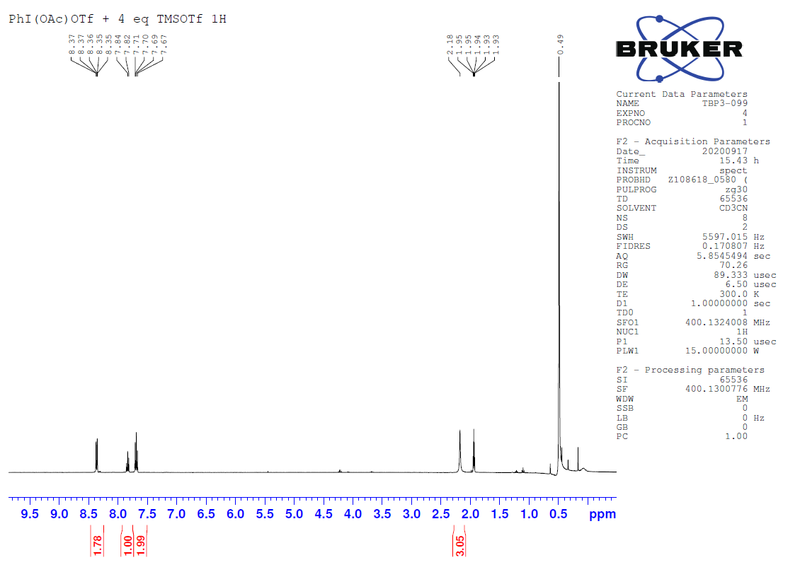

Figure S15. 1H-NMR of PhI(OAc)(OTf) + 4 TMS-OTf in CD3CN.

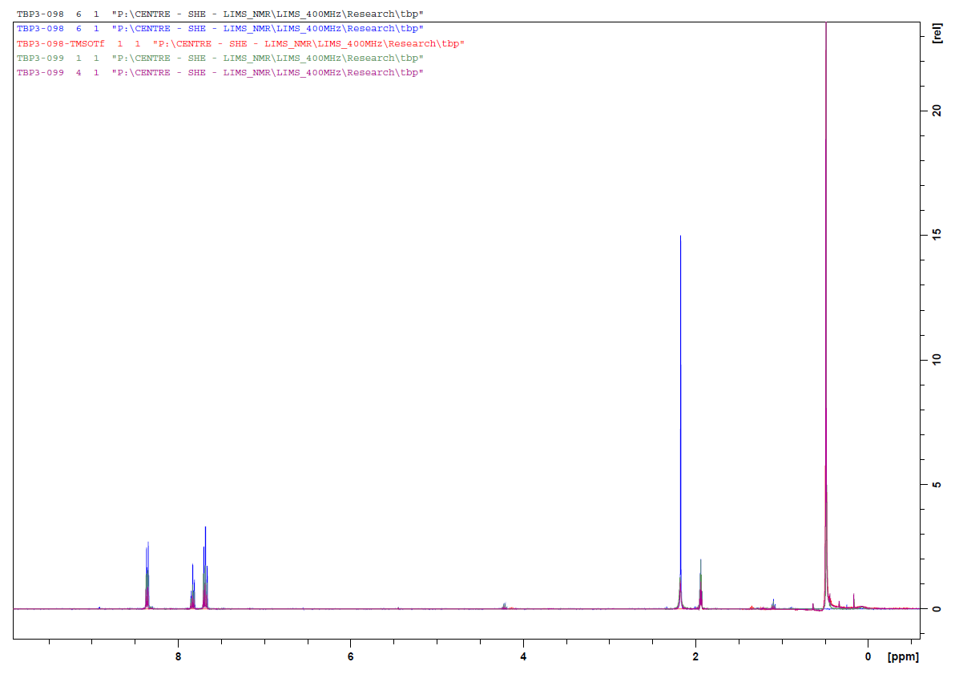

Figure S16. 1H-NMR overlay of the above four spectra.

**2,5-(Dimethylester)PhI(OAc)(OTf)**

In a nitrogen filled glovebox, 3,5-(dimethylester)PhI(OAc)2 (21 mg, 0.048 mmol, 1 eq.) was suspended in CH3CN (1 mL). The mixture was stirred for 5 m to obtain a colourless solution. TMS-OTf (11 mg, 0.048 mmol, 1 eq.) was dissolved in CH3CN (1 mL) and added dropwise to the solution of 3,5-(dimethylester)PhI(OAc)2 over 1 min. The reaction was stirred for 10 m. Volatiles were removed in vacuo leaving a waxy residue. The residue was treated with hexanes (1 mL) and stirred vigorously for 1 m after which precipitation of a white solid was observed. Volatiles were removed in vacuo to afford the title compound as a white solid (23 mg, 90%).

**Reaction of 2,5-(dimethylester)PhI(OAc)(OTf) with one equivalent of TMS-OTf**

In a nitrogen filled glovebox, 2,5-(dimethylester)PhI(OAc)(OTf) (24.1 mg, 0.0456 mmol, 1 eq.) was dissolved in CD3CN (0.6 mL). TMS-OTf (10.1 mg, 0.0522 mmol, 1 eq.) was added in one portion and the mixture was stirred for 15 before being taken for 1H-NMR analysis.

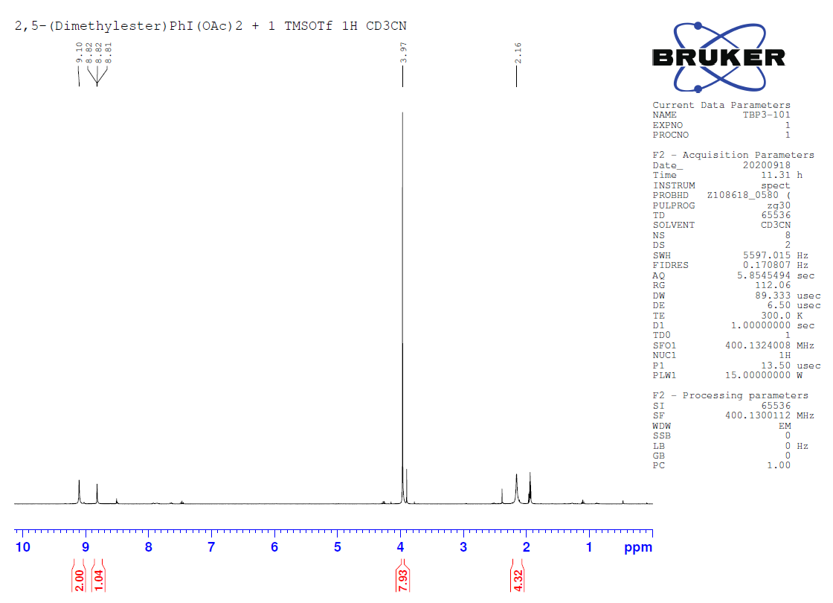

Figure S17. 1H-NMR of 2,5-(Dimethylester)PhI(OAc)(OTf) in CD3CN.

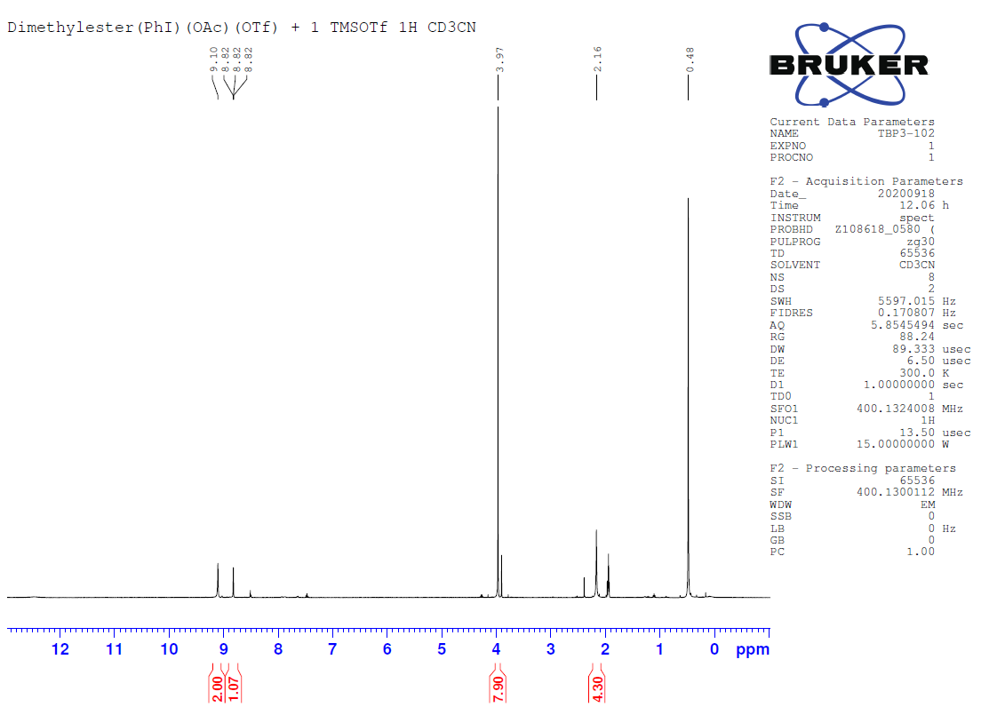

Figure S18. 1H-NMR of 2,5-(Dimethylester)PhI(OAc)(OTf) + 1 equivalent of TMS-OTf in CD3CN.

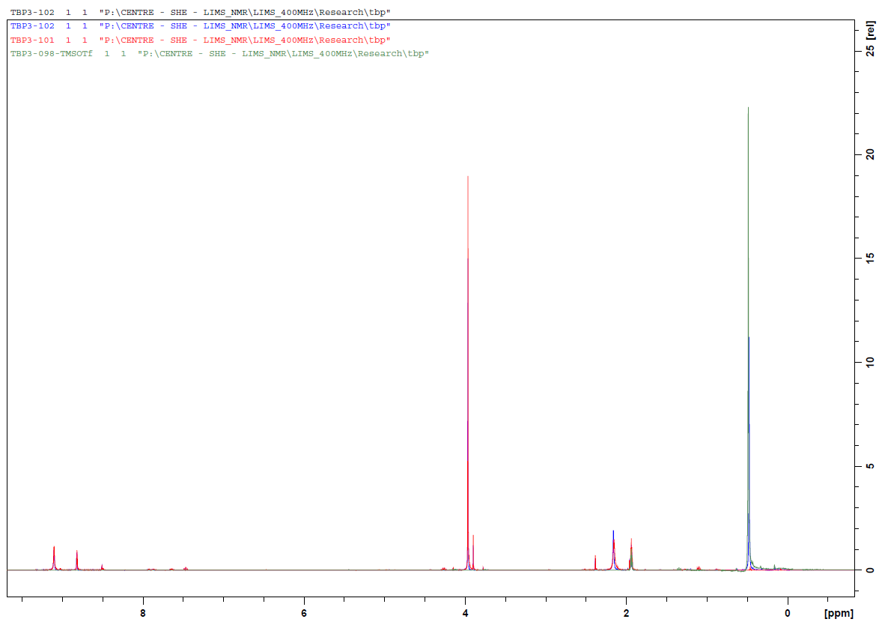

Figure S19. 1H-NMR overlay of the above two spectra and the spectra of TMS-OTf (Figure S13).

COMPUTATIONAL SECTION:

1. Cartesian Coordinates for optimised compound geometries:

All geometry optimisation and vibration frequency calculations were performed at ωPBE/def2-TZVP level within Gaussian 16 using the WebMo platform.3-5 The structure obtained are minima with no negative frequencies. Cartesian coordinates are in Å and energies are given in Hartree. The free energy is calculated at 1 atm and 298 K. The geometry energies and frequency calculations were performed in the solvent phase using a PCM model of acetonitrile, with the exception of the reaction giving Zefirovs’s reagent and the reactions involving the methyl ester substituted ArIX2 system which was considered in the gas phase for computational efficiency.

1. TMS-OTF

ωPBE/def2-TZVP optimised geometry

Electronic Energy = -1370.54007963 Hartree

Free Energy = -1370.432348 Hartree

|  |  |
| --- | --- |
| C | 0.000000 0.000000 0.000000 |
| F | 0.000000 0.000000 1.321257 |
| F | 1.243054 0.000000 -0.443420 |
| F | -0.627678 -1.077083 -0.441586 |
| S | -0.871198 1.508402 -0.581528 |
| O | -2.235211 1.407653 -0.108780 |
| O | -0.040036 2.623831 -0.208081 |
| O | -0.789230 1.268633 -2.112813 |
| Si | -2.073858 0.951068 -3.295345 |
| C | -3.185922 2.432779 -3.244791 |
| H | -2.629411 3.351102 -3.479690 |
| H | -3.990218 2.320618 -3.986783 |
| H | -3.644646 2.543192 -2.252705 |
| C | -2.907262 -0.617662 -2.767107 |
| H | -2.205622 -1.463013 -2.772122 |
| H | -3.332383 -0.517181 -1.759380 |
| H | -3.725843 -0.847299 -3.465284 |
| C | -1.101195 0.792002 -4.861145 |
| H | -0.382108 -0.036381 -4.795669 |
| H | -1.780945 0.589877 -5.701976 |
| H | -0.551922 1.718281 -5.079799 |

1. TfOH

ωPBE/def2-TZVP optimised geometry

Electronic Energy = -961.924632987 Hartree

Free Energy = -961.917551 Hartree

|  |  |
| --- | --- |
| S | -0.847309 -0.134836 0.056537 |
| O | -1.254802 1.142866 -0.747391 |
| H | -1.412242 1.895882 -0.154093 |
| O | -1.221934 -0.009272 1.418196 |
| O | -1.189206 -1.259016 -0.726280 |
| C | 0.982798 0.010717 -0.003183 |
| F | 1.400573 -0.010139 -1.257356 |
| F | 1.512047 -1.006298 0.657461 |
| F | 1.354039 1.149836 0.567940 |

1. PhI(OTf)2

ωPBE/def2-TZVP optimised geometry

Electronic Energy = -2451.87100022 Hartree

Free Energy = -2451.777377 Hartree

|  |  |
| --- | --- |
| S | 0.000000 0.000000 0.000000 |
| C | 0.000000 0.000000 1.835827 |
| F | 1.242845 0.000000 2.296064 |
| F | -0.622003 -1.093542 2.258305 |
| F | -0.635656 1.067611 2.298118 |
| O | 0.756981 1.291943 -0.262412 |
| I | 0.062392 2.883294 -1.467550 |
| C | -0.934297 3.643682 0.154913 |
| C | -0.219241 4.388903 1.073809 |
| C | -0.900865 4.893001 2.163643 |
| C | -2.256286 4.652247 2.306921 |
| C | -2.947720 3.904927 1.369322 |
| C | -2.287031 3.384955 0.274066 |
| H | -2.814667 2.792501 -0.461816 |
| H | -4.007628 3.720637 1.490304 |
| H | -2.782867 5.053982 3.164117 |
| H | -0.368492 5.479755 2.901413 |
| H | 0.838772 4.576724 0.946314 |
| O | -0.657309 4.493803 -2.631810 |
| S | 0.005858 5.857318 -2.741506 |
| C | -1.406475 6.934807 -2.278262 |
| F | -2.416025 6.756822 -3.118269 |
| F | -1.009171 8.199774 -2.334963 |
| F | -1.811802 6.661377 -1.045983 |
| O | 0.997492 6.035472 -1.732368 |
| O | 0.300202 6.175191 -4.095315 |
| O | -1.363573 0.105603 -0.403677 |
| O | 0.771660 -1.131143 -0.381492 |

1. PhI(OAc)2

ωPBE/def2-TZVP optimised geometry

Electronic Energy = -986.091496409 Hartree

Free Energy = -985.943175 Hartree

|  |  |
| --- | --- |
| C | 0.000000 0.000000 0.000000 |
| C | 0.000000 0.000000 1.505952 |
| O | 1.189257 0.000000 2.122737 |
| I | 3.040205 -0.187979 1.255635 |
| C | 2.688331 -2.245994 1.165627 |
| C | 1.887746 -2.823822 2.129492 |
| C | 1.662375 -4.186430 2.060304 |
| C | 2.227954 -4.938618 1.047864 |
| C | 3.025593 -4.333546 0.094784 |
| C | 3.265880 -2.972646 0.144709 |
| H | 3.900294 -2.494656 -0.590054 |
| H | 3.468252 -4.920237 -0.700885 |
| H | 2.045539 -6.005515 1.001203 |
| H | 1.038714 -4.658377 2.809673 |
| H | 1.437160 -2.226648 2.911278 |
| O | 4.861117 -0.551622 0.380850 |
| C | 5.973998 -0.998331 0.978098 |
| O | 6.934923 -1.275396 0.317608 |
| C | 5.952156 -1.126079 2.478463 |
| H | 6.931940 -1.452579 2.813467 |
| H | 5.705758 -0.173678 2.948802 |
| H | 5.205533 -1.858620 2.791518 |
| O | -1.007901 0.002312 2.154426 |
| H | 0.555089 0.853052 -0.391377 |
| H | -1.027647 0.046564 -0.347247 |
| H | 0.465900 -0.909331 -0.384863 |

1. PhI

ωPBE/def2-TZVP optimised geometry

Electronic Energy = -529.292621666 Hartree

Free Energy = -529.231959 Hartree

|  |  |
| --- | --- |
| C | 0.000000 0.000000 0.000000 |
| C | 0.000000 0.000000 1.383225 |
| C | 1.193828 0.000000 2.082001 |
| C | 2.388292 0.000000 1.383482 |
| C | 2.399990 0.000000 -0.000186 |
| C | 1.199900 0.000000 -0.688151 |
| H | 1.207283 0.000000 -1.771756 |
| H | 3.337945 0.000000 -0.541406 |
| I | 4.183706 0.000000 2.423523 |
| H | 1.190968 0.000000 3.164900 |
| H | -0.936317 0.000000 1.928721 |
| H | -0.937478 0.000000 -0.543059 |

1. TMS-OAc

ωPBE/def2-TZVP optimised geometry

Electronic Energy = -637.657292691 Hartree

Free Energy = -637.530983 Hartree

|  |  |
| --- | --- |
| C | 0.000000 0.000000 0.000000 |
| H | 0.000000 0.000000 1.085992 |
| H | 1.022525 0.000000 -0.377042 |
| H | -0.486492 -0.899379 -0.377042 |
| C | -0.720684 1.209196 -0.510591 |
| O | -1.221891 2.050143 0.189505 |
| O | -0.753328 1.263967 -1.842460 |
| Si | -1.510704 2.534726 -2.691048 |
| C | -0.672067 4.138592 -2.285742 |
| H | 0.399508 4.082963 -2.484495 |
| H | -1.083428 4.943081 -2.899312 |
| H | -0.816348 4.397248 -1.237231 |
| C | -3.320415 2.560169 -2.285742 |
| H | -3.781314 1.591180 -2.484495 |
| H | -3.479274 2.810136 -1.237231 |
| H | -3.832301 3.304744 -2.899312 |
| C | -1.225555 2.056290 -4.461846 |
| H | -1.676512 1.087795 -4.683291 |
| H | -1.665576 2.794576 -5.135161 |
| H | -0.159145 1.992150 -4.683291 |

1. PhI(OAc)(OTf)

ωPBE/def2-TZVP optimised geometry

Electronic Energy = -1718.99733953 Hartree

Free Energy = -1718.878942 Hartree

|  |  |
| --- | --- |
| S | 0.000000 0.000000 0.000000 |
| C | 0.000000 0.000000 1.835013 |
| F | 1.253342 0.000000 2.278804 |
| F | -0.614312 -1.083784 2.280851 |
| F | -0.619865 1.073706 2.295244 |
| O | 0.862922 1.221170 -0.289392 |
| I | 3.054113 0.912744 -0.738087 |
| C | 3.167280 2.860609 -0.032219 |
| C | 3.319863 3.891264 -0.949999 |
| C | 3.414105 5.190153 -0.464039 |
| C | 3.348590 5.431282 0.903506 |
| C | 3.193116 4.379583 1.801158 |
| C | 3.105742 3.073205 1.338977 |
| H | 2.993866 2.241561 2.035869 |
| H | 3.144826 4.573946 2.874369 |
| H | 3.420042 6.455176 1.276573 |
| H | 3.534791 6.018306 -1.165065 |
| H | 3.364832 3.696609 -2.023014 |
| O | 5.046711 0.910685 -1.166321 |
| C | 5.887768 0.832798 -0.126692 |
| C | 7.316456 0.789448 -0.571500 |
| H | 7.973074 0.711590 0.300529 |
| H | 7.468435 -0.067493 -1.239925 |
| H | 7.549059 1.699281 -1.139705 |
| O | 5.505301 0.809770 1.016193 |
| O | -1.377363 0.201476 -0.388945 |
| O | 0.689648 -1.222847 -0.382144 |

1. PhIO

ωPBE/def2-TZVP optimised geometry

Electronic Energy = -604.399584164 Hartree

Free Energy = -604.339700 Hartree

|  |  |
| --- | --- |
| C | 0.000000 0.000000 0.000000 |
| C | 0.000000 0.000000 1.376080 |
| C | 1.217610 0.000000 2.033994 |
| C | 2.398796 0.000000 1.316178 |
| C | 2.372684 0.000000 -0.067867 |
| C | 1.165669 -0.000000 -0.740330 |
| H | 1.146133 -0.000000 -1.824642 |
| H | 3.298958 -0.000000 -0.630057 |
| H | 3.348655 0.000000 1.837307 |
| H | 1.239454 0.000000 3.117341 |
| H | -0.946714 0.000000 1.907706 |
| I | -1.869869 0.000000 -0.910643 |
| O | -2.945165 0.000000 0.553918 |

1. TMSOTMS

ωPBE/def2-TZVP optimised geometry

Electronic Energy = -893.6457614 Hartree

Free Energy = -893.459951 Hartree

|  |  |
| --- | --- |
| Si | 0.000000 0.000000 0.000000 |
| O | 0.000000 0.000000 1.641767 |
| Si | 0.801128 0.000000 3.074803 |
| C | 1.460379 -1.706846 3.415233 |
| H | 0.655368 -2.443412 3.439375 |
| H | 2.171934 -2.011113 2.645476 |
| H | 1.974672 -1.740466 4.377984 |
| C | 2.190989 1.228491 3.017359 |
| H | 1.822919 2.232537 2.799056 |
| H | 2.716019 1.265302 3.974194 |
| H | 2.920293 0.961980 2.249745 |
| C | -0.433152 0.481622 4.392832 |
| H | -0.837884 1.476871 4.201766 |
| H | -1.268099 -0.220441 4.421623 |
| H | 0.033869 0.491045 5.379758 |
| C | 1.241188 -1.228491 -0.628065 |
| H | 1.026438 -2.232537 -0.257911 |
| H | 1.232563 -1.265302 -1.719447 |
| H | 2.252340 -0.961980 -0.313921 |
| C | 0.409316 1.706846 -0.618841 |
| H | -0.305127 2.443412 -0.247095 |
| H | 1.406022 2.011113 -0.294165 |
| H | 0.388433 1.740466 -1.710147 |
| C | -1.720511 -0.481622 -0.548170 |
| H | -2.463353 0.220441 -0.165874 |
| H | -1.794453 -0.491045 -1.637511 |
| H | -1.980552 -1.476871 -0.183899 |

1. Triflic Anhydride

ωPBE/def2-TZVP optimised geometry

Electronic Energy = -1847.38515722 Hartree

Free Energy = -1847.374297 Hartree

|  |  |
| --- | --- |
| C | 0.000000 0.000000 0.000000 |
| F | 0.000000 0.000000 1.321750 |
| F | 1.241639 0.000000 -0.449570 |
| F | -0.640543 -1.059855 -0.450951 |
| S | -0.857406 1.537398 -0.543943 |
| O | -2.223772 1.430670 -0.213383 |
| O | -0.035585 2.624006 -0.193686 |
| O | -0.681723 1.332629 -2.135856 |
| S | -1.876662 0.958724 -3.176187 |
| O | -2.373101 -0.326435 -2.880135 |
| O | -2.689697 2.093994 -3.359538 |
| C | -0.734574 0.819865 -4.617425 |
| F | -0.128051 1.970214 -4.831803 |
| F | -1.481009 0.501803 -5.661147 |
| F | 0.157489 -0.127585 -4.397911 |

1. PhI(OH)OI(OH)Ph

ωPBE/def2-TZVP optimised geometry

Electronic Energy = -1285.25952492 Hartree

Free Energy = -1285.096347 Hartree

|  |  |
| --- | --- |
| I | 0.000000 0.000000 0.000000 |
| C | 0.000000 0.000000 2.088142 |
| C | 1.204720 0.000000 2.759703 |
| C | 1.193705 -0.001435 4.143478 |
| C | -0.005177 -0.011520 4.832919 |
| C | -1.201976 -0.018488 4.139150 |
| C | -1.207913 -0.009699 2.755670 |
| H | -2.137737 0.003508 2.203351 |
| H | -2.143348 -0.033002 4.675415 |
| H | -0.007108 -0.015636 5.916444 |
| H | 2.133237 0.007565 4.683097 |
| H | 2.135967 -0.012885 2.209975 |
| O | 1.782783 -1.010955 0.073460 |
| H | 1.629052 -1.939262 0.277148 |
| O | -1.745091 1.044436 0.115931 |
| I | -2.078146 2.596234 -1.136065 |
| C | -0.849324 3.784510 0.069434 |
| C | -0.141729 4.822848 -0.501240 |
| C | 0.670362 5.596967 0.307967 |
| C | 0.761546 5.334633 1.663397 |
| C | 0.039838 4.292390 2.215753 |
| C | -0.771161 3.504776 1.417461 |
| H | -1.329256 2.678327 1.836594 |
| H | 0.103264 4.086477 3.277669 |
| H | 1.397586 5.946535 2.291951 |
| H | 1.237183 6.410366 -0.129215 |
| H | -0.236356 5.031168 -1.558264 |
| O | -2.344477 4.239349 -2.338202 |
| H | -2.962616 4.855281 -1.931659 |

1. PhI(OTf)OI(OTf)Ph (*Gas Phase)

ωPBE/def2-TZVP optimised geometry

Electronic Energy = -3056.28433998 Hartree

Free Energy = -3056.109501 Hartree

|  |  |
| --- | --- |
| S | 0.000000 0.000000 0.000000 |
| O | 0.000000 0.000000 1.507637 |
| I | 1.865173 0.000000 2.712647 |
| C | 1.853998 2.043026 2.469294 |
| C | 1.101384 2.817684 3.329476 |
| C | 1.116093 4.187174 3.154622 |
| C | 1.871621 4.749736 2.141538 |
| C | 2.615945 3.952076 1.292652 |
| C | 2.611687 2.579254 1.447538 |
| H | 3.165291 1.942700 0.770490 |
| H | 3.197640 4.396444 0.494694 |
| H | 1.874766 5.824982 2.007967 |
| H | 0.529556 4.816320 3.812661 |
| H | 0.511221 2.368174 4.117884 |
| O | 3.499630 0.124013 3.826102 |
| I | 3.592978 -0.508439 5.693103 |
| C | 2.348793 0.987975 6.370398 |
| C | 1.023787 0.687069 6.624066 |
| C | 0.195870 1.697062 7.076037 |
| C | 0.699691 2.971279 7.266673 |
| C | 2.030651 3.247749 7.010684 |
| C | 2.874091 2.250770 6.560163 |
| H | 3.923643 2.448265 6.386776 |
| H | 2.423563 4.243067 7.177076 |
| H | 0.048194 3.756415 7.631749 |
| H | -0.843894 1.481769 7.289360 |
| H | 0.643842 -0.317991 6.490911 |
| O | 3.621283 -1.144446 7.816842 |
| S | 4.538288 -0.501951 8.827358 |
| O | 5.153847 0.670533 8.285924 |
| O | 3.957316 -0.470075 10.121214 |
| C | 5.876679 -1.752677 8.903718 |
| F | 5.415377 -2.912965 9.351693 |
| F | 6.845876 -1.333089 9.704223 |
| F | 6.383832 -1.943479 7.681114 |
| O | 1.283810 0.370605 -0.511222 |
| O | -0.675812 -1.126948 -0.537079 |
| C | -1.098678 1.431607 -0.329555 |
| C | -2.303155 1.227763 0.190642 |
| F | -1.218321 1.604939 -1.639720 |
| F | -0.591103 2.543830 0.202238 |

1. Ph(COOMe)2I(OAc)2 (*Gas Phase)

ωPBE/def2-TZVP optimised geometry

Electronic Energy = -1441.70710962 Hartree

Free Energy = -1441.485445 Hartree

|  |  |
| --- | --- |
| C | 0.000000 0.000000 0.000000 |
| C | 0.000000 0.000000 1.505803 |
| O | 1.185087 0.000000 2.120458 |
| I | 2.991284 -0.598921 1.309727 |
| C | 2.364330 -2.533682 1.760215 |
| C | 1.655248 -2.744236 2.926529 |
| C | 1.259562 -4.032467 3.236396 |
| C | 1.579069 -5.078559 2.386776 |
| C | 2.261288 -4.836586 1.209707 |
| C | 2.669570 -3.551712 0.887347 |
| H | 3.227153 -3.385910 -0.026281 |
| C | 2.590469 -5.923161 0.238037 |
| O | 2.241726 -7.125621 0.684535 |
| C | 2.535160 -8.210391 -0.193432 |
| H | 2.198830 -9.107279 0.318857 |
| H | 2.006437 -8.086045 -1.137615 |
| H | 3.605610 -8.258525 -0.388561 |
| O | 3.108207 -5.724455 -0.825716 |
| H | 1.295790 -6.087649 2.655464 |
| C | 0.598448 -4.362009 4.545145 |
| O | -0.419897 -3.614513 4.965739 |
| C | -1.171024 -2.775762 4.088278 |
| H | -2.193696 -2.797382 4.457148 |
| H | -0.805376 -1.750742 4.111638 |
| H | -1.153676 -3.146765 3.064316 |
| O | 1.002088 -5.267837 5.214811 |
| H | 1.421077 -1.916639 3.582847 |
| O | 4.702085 -1.408600 0.559935 |
| C | 5.800183 -1.771220 1.248367 |
| C | 5.758497 -1.628630 2.746393 |
| H | 6.702771 -1.978075 3.152713 |
| H | 5.608073 -0.587293 3.034560 |
| H | 4.944987 -2.217893 3.172593 |
| O | 6.754009 -2.187163 0.659145 |
| O | -1.013230 0.009250 2.151465 |
| H | 0.647506 0.783402 -0.394230 |
| H | -1.016405 0.153435 -0.350124 |
| H | 0.361867 -0.956857 -0.381202 |

1. Ph(COOMe)2I(OTf)(OAc) (*Gas Phase)

ωPBE/def2-TZVP optimised geometry

Electronic Energy = -2174.60447702 Hartree

Free Energy = -2174.409720 Hartree

|  |  |
| --- | --- |
| S | 0.000000 0.000000 0.000000 |
| O | 0.000000 0.000000 1.478095 |
| I | 2.266757 0.000000 2.519588 |
| C | 2.084052 2.036291 2.258643 |
| C | 1.285843 2.740612 3.133481 |
| C | 1.163496 4.104964 2.945414 |
| C | 1.829388 4.726466 1.903285 |
| C | 2.621860 3.992164 1.041782 |
| C | 2.750717 2.624577 1.209081 |
| H | 3.347822 2.059212 0.505575 |
| C | 3.366086 4.615299 -0.092920 |
| O | 4.145811 4.017053 -0.781045 |
| O | 3.069861 5.902008 -0.247272 |
| C | 3.742701 6.557004 -1.319660 |
| H | 3.388302 7.583849 -1.310584 |
| H | 4.820803 6.521558 -1.167742 |
| H | 3.500384 6.076007 -2.266386 |
| H | 1.715273 5.794608 1.773599 |
| C | 0.317478 4.948512 3.839332 |
| O | 0.194571 6.135066 3.713327 |
| O | -0.283287 4.236767 4.790952 |
| C | -1.121695 4.982223 5.670345 |
| H | -1.534366 4.262123 6.371318 |
| H | -0.540897 5.739614 6.195291 |
| H | -1.918142 5.469431 5.109490 |
| H | 0.754175 2.254074 3.939445 |
| C | 4.162157 0.288258 3.583260 |
| O | 4.534338 1.378003 3.829389 |
| O | 4.801373 -0.815725 3.913953 |
| C | 4.300517 -2.100718 3.555337 |
| H | 5.018468 -2.813954 3.949115 |
| H | 3.330431 -2.286182 4.020743 |
| H | 4.248273 -2.211206 2.471154 |
| O | 1.297839 0.345364 -0.521832 |
| O | -0.686448 -1.102720 -0.585380 |
| C | -1.049039 1.456352 -0.376433 |
| F | -2.274217 1.299961 0.117550 |
| F | -1.140705 1.635026 -1.690208 |
| F | -0.526049 2.566863 0.159041 |

1. Ph(COOMe)2I(OTf)2 (*Gas Phase)

ωPBE/def2-TZVP optimised geometry

Electronic Energy = -2907.50808792 Hartree

Free Energy = -2907.339748 Hartree

|  |  |
| --- | --- |
| S | 0.000000 0.000000 0.000000 |
| O | 0.000000 0.000000 1.535149 |
| I | 1.753594 0.000000 2.681571 |
| C | 1.871821 2.038390 2.454793 |
| C | 1.119320 2.836587 3.293943 |
| C | 1.201678 4.206452 3.129735 |
| C | 2.026429 4.743174 2.155661 |
| C | 2.774675 3.919770 1.334962 |
| C | 2.698883 2.545478 1.475660 |
| H | 3.276835 1.912759 0.813876 |
| C | 3.686945 4.451282 0.277738 |
| O | 4.387137 3.752876 -0.401036 |
| O | 3.633138 5.775101 0.181919 |
| C | 4.483512 6.349872 -0.808636 |
| H | 4.318281 7.422175 -0.756581 |
| H | 5.524780 6.110931 -0.596518 |
| H | 4.224002 5.968568 -1.795301 |
| H | 2.076584 5.819189 2.050715 |
| C | 0.425331 5.150489 3.988750 |
| O | 0.496434 6.343994 3.890640 |
| O | -0.346876 4.517369 4.865039 |
| C | -1.110092 5.357867 5.728452 |
| H | -1.670500 4.689263 6.375479 |
| H | -0.449101 5.994219 6.315198 |
| H | -1.784477 5.983878 5.145679 |
| H | 0.492870 2.415793 4.068251 |
| O | 3.504301 0.056722 3.835359 |
| S | 3.509406 0.398384 5.330450 |
| O | 2.270329 1.000597 5.699616 |
| O | 4.062540 -0.659535 6.090313 |
| C | 4.763033 1.739609 5.329979 |
| F | 5.923421 1.289385 4.880758 |
| F | 4.912133 2.181868 6.569657 |
| F | 4.360229 2.744947 4.557417 |
| O | 1.293157 0.346767 -0.488377 |
| O | -0.698808 -1.122610 -0.503779 |
| C | -1.082276 1.452387 -0.300202 |
| F | -2.277000 1.258705 0.236900 |
| F | -1.210083 1.625669 -1.606587 |
| F | -0.542882 2.546462 0.231289 |

1. Bond distances for bound triflates
2. Experimental Bond lengths from literature reports:

|  |  |  |
| --- | --- | --- |
| Bond | Bond lengths (Å) | |
| Triflic Acid6 | TMS-OTf7 |
| S-O | 1.558 | 1.544 |
| O=S | 1.418 | 1.421 |
| S-C | 1.833 | 1.851 |
| C-F | 1.332 | 1.329 |

1. Calculated bond distances for Triflic Acid
2. ωPBE

|  |  |
| --- | --- |
| Bond | def2-TZVP |
| S-O | 1.573 |
| O=S | 1.416 |
| S-C | 1.837 |
| C-F | 1.323 |

1. Calculated bond distances for TMS-OTf
2. ωPBE

|  |  |
| --- | --- |
| Bond | def2-TZVP |
| S-O | 1.532 |
| O=S | 1.419 |
| S-C | 1.834 |
| C-F | 1.325 |

1. OPTIMISED GEOMETRIES:

|  |  |  |
| --- | --- | --- |
| Sr. No. | Molecular formula | Structure |
| 1. | Triflic Acid: HOTf |  |
| 2. | TMS-OTf |  |
| 3. | PhI(OTf)2 |  |
| 5. | PhI(OAc)2 |  |
| 7. | PhI |  |
| 10. | TMS-OAc |  |
| 11. | PhI(OAc)(OTf) |  |
| 12. | PhIO |  |
| 13. | TMSOTMS |  |
| 14. | Triflic Anhydride |  |
| 15. | PhI(OH)OI(OH)Ph |  |
| 16. | Zefirov’s Reagent |  |
| 17. | PhI(COOMe)2I(OAc)2 |  |
| 18. | PhI(COOMe)2I(OAc)(OTf) |  |
| 19. | PhI(COOMe)2I(OTf)2 |  |

1. FREE ENERGY CALCULATIONS:
2. PhI(OAc)2 + TMS-OTf → PhI(OAc)(OTf) + TMS-OAc

∆G = -67 KJ/Mol



1. PhI(OAc)(OTf) + TMS-OTf → PhI(OTf)2 + TMS-OAc

∆G = 30 KJ/Mol



1. PhI(OAc)2 + 2 TMS-OTf → PhI(OTf)2 + 2 TMS-OAc

∆G = -37 KJ/Mol



1. PhIO + Triflic Anhydride → PhI(OTf)2

∆G = -166 KJ/Mol



1. PhIO + 2 Triflic Acid → PhI(OTf)2 + H2O

∆G = - 69 KJ/Mol



1. PhIO + 2 TMS-OTf → PhI(OTf)2 + TMSOTMS

∆G = -41 KJ/Mol



1. PhI(OH)OI(OH)Ph + 4 TMS-OTf → 2 PhI(OTf)2 + 2 TMSOTMS + H2O

∆G = -100 KJ/Mol



*Geometry and single point energy calculations for further reactions were considered in the gas phase.

1. 2 PhIO + Triflic Anhydride → PhI(OTf)OPhI(OTf) : ∆G = -233 KJ/Mol.



1. Ph(COOMe)2I(OAc)2 + TMS-OTf → Ph(COOMe)2I(OTf)(OAc) + TMS-OAc

∆G = -43 KJ/Mol



1. Ph(COOMe)2I(OTf)(OAc) + TMS-OTf → Ph(COOMe)2I(OTf)2 + TMS-OAc

∆G = -58 KJ/Mol



1. Ph(COOMe)2I(OAc)2 + 2 TMS-OTf → Ph(COOMe)2I(OTf)2 + 2 TMS-OAc

∆G = -101 KJ/Mol



REFERENCES:

1. Aprile, A.; Iversen, K. J.; Wilson, D. J. D.; Dutton, J. L. Te(II)/Te(IV) mediated C-N bond formation on 2,5-diphenyltellurophene and a reassignment of the product from the reaction of PhI(OAc)2 with 2 TMS-OTf. *Inorg. Chem.* **2015,** 54, 4934-4939.

2. de Vries, R. H.; Viel, J. H.; Oudshoorn, R.; Kuipers, O. P.; Roelfes, G. PhI=O. *Chem. Eur. J.* **2019,** 25, 12698-12702.

3. Heyd, J.; Scuseria, G. E. Hybrid functionals based on a screend Coulomb potential. *J. Phys. Chem.* **2003,** 118, 8207.

4. Heyd, J.; Scuseria, G. E. Assessment and validation of a screened Columb hybrid density functional. *J. Phys. Chem.* **2004,** 120, 7274.

5. Weigend, F.; Ahlrichs, R. Balanced basis sets of split valence, triple zeta valence and quadruple zeta valence quality for H ot Rn: design and assessment of accuracy. *Phys. Chem. Chem. Phys.* **2005,** 7, 3297-3305.

6. Schultz, G.; Hargittai, I.; Seip, R. Electron diffraction investigation of the molecular structure of trifluoromethanesulphonic acid (triflic acid). *Z. Naturforsch.* **1981,** 36a, 917-918.

7. Lestard, M. E. D.; Tuttolomondo, M. E.; Varetti, E. L.; Wann, D. A.; Robertson, H. E.; Rankin, D. W. H.; Altabef, A. B. Investigation of the gas-phase structure and rotational barrier of trimethylsilyl triflouromethanesulfonate and comparison with covalent sulfonates. *J. Mol. Struc.* **2010,** 984, 376-382.