PHIL KAFCALOUDES
RMIT University, Australia
La Trobe University, Australia

Going the Way of the Ancients

ABSTRACT  This paper examines some of the issues around telling true stories in a fictional style. The author examines this issue as part of a PhD by creative work and exegesis involving the writing of a performance piece based on the activities of Olga Stambolis, a spy in Greece during World War II. Stambolis was a resistance fighter, rescuing Australian, British and New Zealand airmen caught behind enemy lines in central, western and northern Greece. Part of this paper examines Homer’s writing of The Odyssey, noting similarities not only in storytelling modalities, but with the methods of embellishment used by Greek writers including Homer and Herodotus, a style that led Plutarch to call Herodotus “the Father of Lies” for his tendency to move beyond the strict facts in his Histories (440BC). | KEYWORDS  Australia  fiction  Greece  Herodotus  Homer  spies
INTRODUCTION

Olga Stambolis, was a Greek-Australian spy in World War II. As the threat grew of invasion of Greece by the Italians in 1940, and then the Germans in 1941, Olga Stambolis was recruited and trained by the British Government’s Special Operations Executive (SOE) to resist the German occupiers in Greece from 1941. The SOE may well have considered her to be a perfect candidate: Stambolis was a British subject (although born in Greece, she had been an Australian resident for many years) who could speak six languages including German and Italian; and was believed to have no close family in Greece, and thus no family connections that could be used against her. Stambolis had also been an amateur actress. Stambolis was taught how to sabotage, kill and rescue. Using the cover as an employee with ambassadors, she claimed to be responsible for rescuing Australian, New Zealand and British flyers caught behind the battle lines as the Germans made their push towards Athens from the north of the country. Meanwhile in Australia, her family, who believed her dead, were facing their own wartime challenges. Her daughter Nellie had moved to Darwin just before Japan bombed the town. In Sydney, Stambolis’ husband, who has not heard from his wife for some time, had her declared dead, remarried and had two children with his new wife. Through the entwined stories of mother and daughters, the Stambolis story is an epic involving two countries and two sets of lives from 1916 to 1943.
I chose to tell the story of Stambolis, who is my maternal grandmother, in a novel titled Someone Else’s War. I am writing an adaptation of the novel into a stage drama, tentatively titled Unbroken.
There were several issues in the telling of this story, all involving the nature of truth in historical fiction and knowing how far to deviate from a story’s factual base. Throughout history factual stories have been put into a fictional context. In his histories, Shakespeare invented dialogue and facts for all his major characters, Richards II and III, Henrys IV, V, VI and VIII, King John and Pericles. Even his dramas told of real characters such and Antony and Cleopatra as well as Julius Caesar. But Shakespeare did not write histories. He dramatised and invented dialogue, doing this so convincingly that it could be argued that his version of Richard III has become the popular perception of what this king was like.
As the writing of Someone Else’s War progressed, parallels became evident with Shakespeare’s depictions of true figures such as Richard III, but also with ancient Greek writers Homer and Herodotus who wrote of events they had not witnessed, such as the Trojan War, and may have relied on oral histories as their primary source of fact in this era of the genesis of written histories.

DELINEATING TRUTH IN FICTION: AN ANCIENT PROBLEM

Art Lies in Concealing Art: Ovid

Homer’s The Odyssey and The Iliad could be counted among the oldest existing texts. The Odyssey tells the story of Odysseus, and his attempt to return home to Greece after the Trojan War. It must be acknowledged that while Someone Else’s War presents a fictionalised version of true events, The Odyssey presents a story that may never have happened. There is no evidence that Odysseus was kept in limbo for ten years, seduced a goddess, nor had his followers eaten by a gigantic one-eyed man. Academics even differ about whether Troy existed in Turkey at all, let along whether the Trojan War occurred.
The evidence of Odysseus’ own existence is scant. In 2010 a team of archeologists discovered what they claimed to be Odysseus’ house but even this did not stop all doubt:
The claim [about the house belonging to Odysseus] will be greeted with scepticism by the many scholars who believe that Odysseus, along with other key characters from the Homer's epic such as Hector and Achilles, were purely fictional.

In addition to these doubts, there are other elements in Homer’s writing that lend support to the theory that the book is not a retelling of a factual story. Throughout The Odyssey there are regular interactions with Gods and Goddesses (Poseidon, Zeus, Athene); and with mythological elements (The Bag of Winds). This can take The Odyssey into the realm of being a mythological story, a fairy tale, perhaps even a metaphor that was never intended by its author to be a direct telling of true events. It could well be that Homer was the first writer to tell a story of a what may have been a true (and perhaps mythological) character in an embellished and fictionalised way.

FICTIONALISING A TRUE CHARACTER

In Someone Else’s War, I wished to bring my grandmother’s story to life with a conscious decision to go inside her mind, a mind I never knew. This journey was made more difficult because she left no evidence of her point-of-view.
Herodotus, a Greek writer who lived four hundred years after Homer, is regarded as the first historical writer for his series of texts on the history of the world, The Histories. Cicero called him ‘The Father of History’. But it was Herodotus’ want to quote from the minds of his characters, quotes he could not possibly know were true, that led Plutarch to label Herodotus ‘The Father of Lies’ in his work On The Malice of Herodotus:
But thou, O Herodotus, transferest the full moon from the middle to the beginning of the month, and at the same time confoundest the heavens, days, and all things; and yet thou dost pretend to be the historian of Greece!
Plutarch then attacks Herodotus’ use of literary devices to aid the flow of his story-telling:
He is an acute writer, his style is pleasant, there is a certain grace, force, and elegancy in his narrations; and he has, like a musician, pronounced his discourse, though not knowingly, still clearly and elegantly. These things delight, please, and affect all men. But as in roses we must beware of the venomous flies called cantharides; so must we take heed of the calumnies and envy lying hid under smooth and well-couched phrases and expressions, lest we imprudently entertain absurd and false opinions of the most excellent and greatest cities and men of Greece.
Here then, Plutarch considers invention and personalising to be lying. But did Herodotus have any choice in this method of storytelling? It may be that each of these authors had the bare facts of a story which was valuable to history, and the storytelling methodology needed some invention to bring it to life. It is an issue that the writing of Someone Else’s War had to address: the lack of source material.

THE PROBLEM: RELIANCE ON ORAL HISTORIES

The novel, Someone Else’s War is an historical fiction novel. But it was not necessarily always going to fall into this category. The major factor in the decision to fictionalise the story is the fact is that Stambolis wrote no diaries. She left no written note of her exploits.
For the facts of the Stambolis story there was a great reliance on oral histories. These oral histories were not from the protagonist herself. Rather, the histories were second hand, coming from her daughters and son. The protagonist was long dead when the story was being written, so she was not able to be questioned. This meant the truth of the family’s oral histories needed to be verified, a process that was not always successful.
There were some documents left by Stambolis which verified some of the things she claimed in her own oral history passed down to her children, such as her claim against the British Government for personal possessions taken by the Germans (see Figure 1). This document directly refers to her gaoling in 1941.
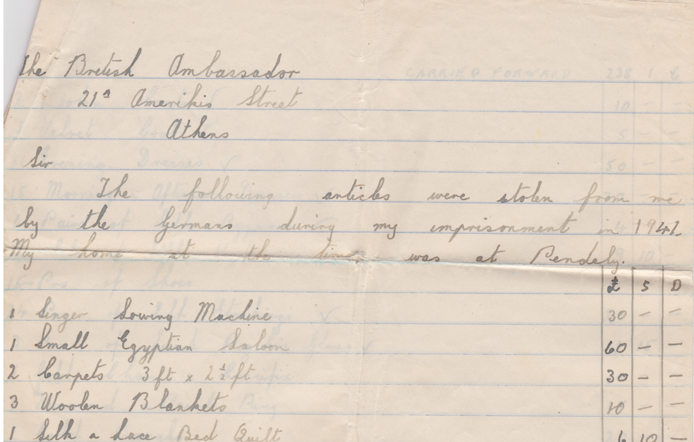
Figure 1: Olga Stambolis’ Claim against the British Government
The Stambolis Family Collection

There were also passes and references (see Figure 2) that supported Stambolis’ claim that she worked in diplomatic circles:

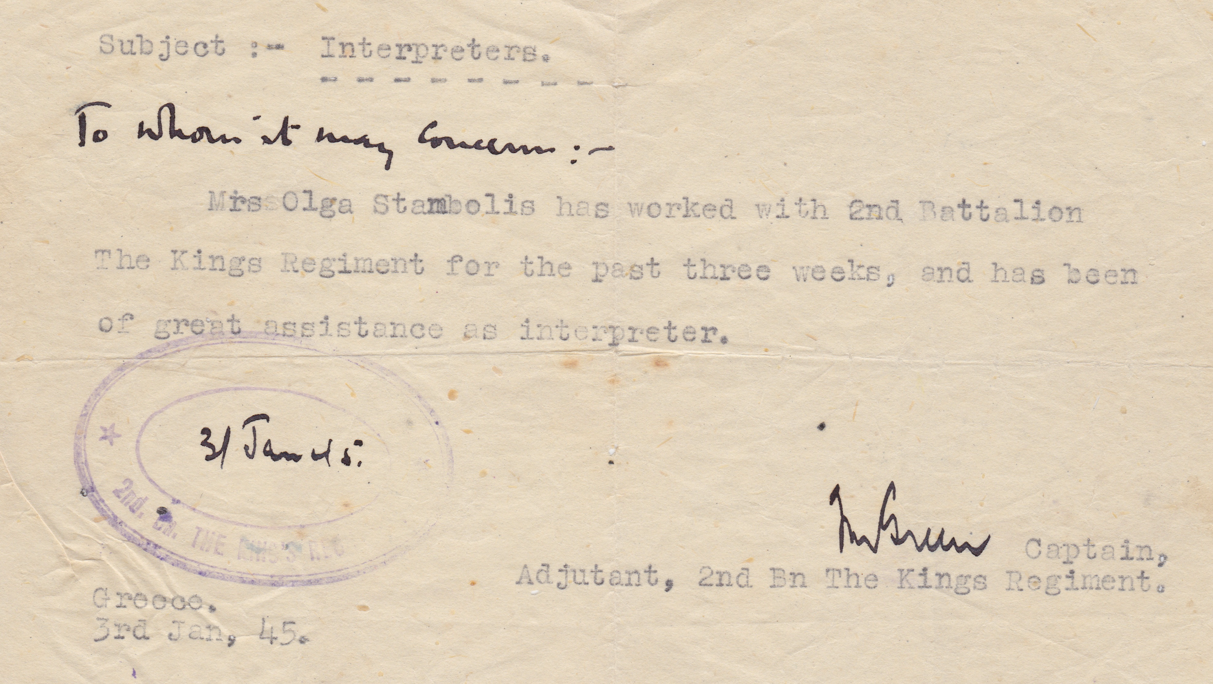
Figure 2: British Army Reference
The Stambolis Family Collection

However, the detail of Stambolis’ actions and involvement in World War II in Greece were not in these documents. The oral histories relied upon were imperfect histories, as might be expected from stories told some decades after they were first revealed by Stambolis herself. Relying on what could be imperfect oral histories is not new in literature. Going back once again to the ancient writers, they needed necessarily to rely on oral histories. There was no alternative, except perhaps if they had personally witnessed, or were participants in, the events they were writing about.
Because of this, and because I never had the opportunity to talk to Stambolis about her time in Greece, there were no first-hand accounts of her activities, just the rich oral history passed onto her children. So while there was plenty of source material, it was undocumented source material with much of the detail unsubstantiated. Getting confirmatory material for what Stambolis did in Greece during the War posed difficulties. What followed was twelve years of research, trying to find facts to corroborate the oral histories. These facts were difficult to find, and her claims of being a spy were not able to be verified in a conclusive way: a reflection of the passage of time and the inherent secrecy of spy work. In contrast, the activities in Australia involving Stambolis’ husband Michael and his daughters in Sydney and Darwin were easier to certify, because early drafts of the novel could be shown to Nellie and to several other family members who were present at the time of the events. Even so, having this multi-faceted story was ambitious, particularly as source material about Stambolis herself was limited.
So it was at this point that a decision needed to be made: must the book be a factual account, using the scant facts of Stambolis story? If so, the part of the book devoted to Stambolis’ activities was going to be very short. An alternative was to consider turning it into an account that used all the facts available but in the framework of a piece of historical fiction.
This option seemed very attractive because times could be manipulated and places and characters invented. For this novel, a strict rendering of factual timelines and character development may lead to a lessening of dramatic tension. In the novel Stambolis begins with her having a great deal of self-doubt and perhaps a form of mental illness. As written, Stambolis’ work in the resistance boosts her confidence. She finds purpose. She gets stronger. Although she wavers at times, these times are for dramatic purpose: memory of her children; remorse for the killings she has committed. But for the most part there is character development. When talking of the freedom of an historical novel to amend facts for the sake of the story, the there is a scene early in the novel where the Greek prime minister John Metaxas shoots a protestor dead . This was a scene that I felt was essential for the character of Metaxas to be established, but this particular event was fiction. It could only be included if the story was told as historical fiction.
With this mix of fact and fiction, I made the decision for Someone Else’s War: use the facts available; make sure the context was true; tell the story of this war and of a woman spy in it. However, to make this a credible work, the publication would need to clearly state that this is an historical fiction piece, that was only loosely based on a true story. This allowed a broadening of the story and the inclusion of fictional elements to help tell the story of the Greek experience under occupation as well as of a woman’s role in that situation.
This was however not a strict work of fiction. It was more a hybrid historical fiction because there are real people in the novel. The real names of the Greek leadership and some other historical figures such as some of the resistance fighters are used. Stambolis, her husband, children and Jean are all real characters. Their real names are used. The writing of what was to become Someone Else’s War followed the Homeric tradition of using research and knitting her story into established facts to provide a piece of work which provided much truth.Among the scenarios invented for the novel was a rape scene. In the novel Stambolis is raped on the day the Germans entered Athens. Although many women were raped in Greece Stambolis never claimed to be raped. This was invented for a number of reasons: a final mo tivating force for her; a symbolism of what was happening to the ancient capital on that day; a device to show her personality as she responds; and to give an example of what was happening to other women. Some scenarios were created using only the briefest of primary information. This included an ongoing scenario where Stambolis is given a house in the Athens suburb of Pendeli by the French ambassador. This house was later confiscated by the German command while Stambolis was in Averoff prison.
The factual basis for this story came not only from oral history, but also from a single document lodged by Stambolis with the British Ambassador claiming compensation for the lost and damaged items in the house. From this document was knitted a series of scenarios, including the ambassador giving Stambolis the house, Stambolis moving in, exploring the furniture left by the ambassador, the Germans showing interest in the house and finally the decrepit state of the house when she finally returns to it after the Germans have moved out.
It was not just the scenarios that were invented. Also invented were characters, such as a character in Greece named Nicky, who was deaf. Stambolis had a real son who was deaf, and who is present in the Australian side of the novel. This Greek Nicky was placed in the novel as a literary device, to be a subtle link between the two sides of the world. Through the invention of Nicky, Stambolis’ maternal side was shown in addition to offering an opportunity to demonstrate how issues around disability were approached in the two countries at that time. Other invented characters were drawn to give an insight into the wider personalities in the resistance. This included a man known only as The Captain who was the leader of an Athens cell in the resistance. He, along with another fictional resistance fighter, Stavros, were both introduced as contrasts. While both were capable and passionate, they had very different personalities. The Captain was tough and confident (a fact demonstrated by his murder of a suspected informant). Stavros was more fragile minded, badly affected by the loss of a relative. As a third contrasting character, there was a man who was enthusiastic but child-like; not at all tough; glorying in the killings and the successes of the underground, but certainly unable to be relied upon.
The final version of the novel was a mixture of narrative styles which include a fictional diary, a fictional re-telling of historical events, and a third-person recounting of events occurring in Greece, Egypt and Australia while also moving backwards and forwards through a time period that extended between World War I through to 1952. These movements were chosen because I came to the view during the writing process that these were the most effective ways to tell this story, filling in the gaps in the story while staying honest about the nature of the work.

CONCLUSION

From the earliest days of existing written stories, authors have used invention and amendment of facts in their story-telling. They may have done this to increase the impact of their stories; to put the stories into a more logical timeline; to cut out unneeded detritus; or they may simply have done it to increase the entertainment value to the reader. Dramatic purpose in written work has also required that the stories are personal, when there has been little or no information on that personal story. Feelings, tone, thoughts, dialogue, detail of places and times may be unknown. The ancients successfully negotiated that information gap and provided works that have endured for more than two thousand years and have been transformed into many other versions. It is a testament to those ancient writers that their works are still of interest today.
Many of the same issues that faced Herodotus and Homer applied to the writing of Someone Else’s War. In all three cases the available information for the basis of the writings were oral histories. All the stories had gaps which needed to be filled if the narrative was going to make sense; to lead the reader through the story successfully.
As outlined, Someone Else’s War contains several disclaimers as to whether the novel is a strict retelling of fact, but there will always be people who do not take these disclaimers on board. This however does not mean this historical fiction style has no worth. Perhaps, it may be argued, if people are so absorbed in the story and choose to believe that they are true, then this is in itself a measure of the success of the writing. They entertain. A problem may exist where a work is depicted as a non-fiction work, but contains fictional elements without any notification to the reader that these elements are not true.

REFERENCES

1 Phil Kafcaloudes, Someone Else’s War, (2011 SEW Books, Melbourne).
J. Wilford, Was Troy a Metropolis? Homer Isn't Talking, (2002 The New York Times, viewed 5 August 2018), https://archive.nytimes.com/www.nytimes.com/learning/teachers/featured_articles/20021023wednesday.html
N. Squires, Greeks discover Odysseus' palace in Ithaca, proving Homer's hero was real, (2010 The Telegraph, viewed 24th August 2017) <http://www.telegraph.co.uk/news/worldnews/ Europe/greece/7962445/Greeks-discover-Odysseus-palace-in-Ithaca-proving-Homers-hero-was-real.html >.
Cicero, On the Republic. On the Laws. Translated by Clinton W. Keyes, (1928 Harvard University Press, Cambridge), 1.5
W. Goodwin, Plutarch’s Morals. Translated from the Greek by Several Hands, (1878; Little, Brown & Co, Boston). Section 26, 10.
Ibid., Section 43, 21.
Phil Kafcaloudes, Someone Else’s War, (2011 SEW Books, Melbourne), 25.
N. Fagge, I despise them. Germany is the enemy, (2015 The Daily Mail, viewed 5 July 2018), http://www.dailymail.co.uk/news/article-3152216/I-despise-Germany-enemy-Greek-survivors-Nazi-massacre-say-No-vote-wasn-t-just-austerity-continued-resistance-against-occupation.html ACKNOWLEDGEMENTS I am grateful to Rachel Franks for her support for my paper and for accepting a presentation of this paper at the 9th Annual International Conference of the Popular Culture Association of Australia and New Zealand (Auckland, New Zealand). Also, thanks to my PhD thesis supervisors, Professor Chris Mackie, Dr Nasya Bahfen and Dr Steinar Ellingsen for their enthusiasm and suggestions for the line of research for this project. I am also grateful to the reviewers for their valuable feedback on this work. CONTRIBUTOR DETAILS Phil Kafcaloudes is a lecturer and industry fellow in the Media & Communication department at RMIT University in Melbourne. He came to academia after 30 years in broadcasting, including as a television political reporter and as the long-term host of the breakfast program on the ABC’s Radio Australia. Phil is a Churchill Fellow, having studied the effects of trauma on journalists. He has written three books, including a journalism text, a book of short stories, and the novel Someone Else’s War which is being adapted into a play as part of a PhD he is completing through La Trobe University in Melbourne. CONTACT: phillip.kafcaloudes@rmit.edu.au SUGGESTED CITATION Kafcaloudes, Phil (2018), “Going the Way of the Ancients,” Peer Reviewed Proceedings of the 9th Annual Conference Popular Culture Association of Australia and New Zealand (PopCAANZ), Auckland, New Zealand, 2-4 July, 2018, P. Mountfort (ed), Sydney: PopCAANZ. Available from http://popcaanz.com/conference-proceedings-2018/.

