Step by step guide on completing task using ARIADNE
Once we click the link sent in the email, we will see the following home page.
We can see two red boxes for the two tasks. We can begin with either of the two tasks. Our step by step guide will provide assistance for both these tasks. However, we will begin with the prioritizing task (mentioned as importance in the first red box).
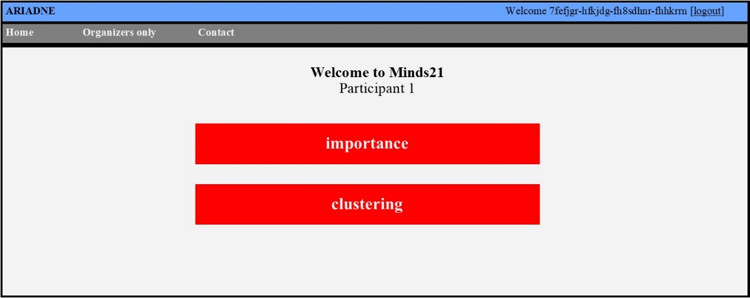
Figure 1: Ariadne programme home page
Here on the top right corner we can see ‘logout’. Click it if you want to logout at this time and visit the program at a later time.

Task 1: Prioritization
In this task, we will divide the individual statements on nurse-doctor communication into five equal groups from 1 ‘least important’ to 5 ‘most important’.
Step 1: Click on “Importance”
Once we click the importance (figure 1), it will take us to this page (figure 2).
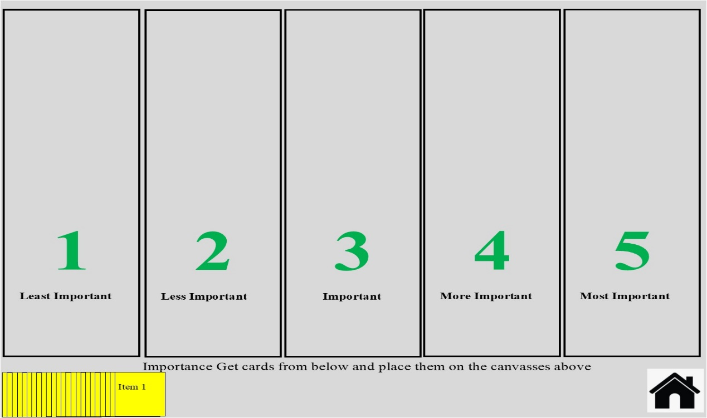
Figure 2: Prioritizing task home page
Here we can see five vertical coulumns and a pack of yellow cards (at the lower left corner) containing the statements generated from the interview. The ‘home ’ button at the lower right corner allows us to save the task and exit.

Step 2: Drag the cards into the vertical columns
Now we need to drag each card from the pile and place it into In one of the five vertical columns. These cards needs to be organized into the columns based on what you thinks is important for nurse-doctor communication. The column at the left represents ‘least important’ whereas the column at the extreme right represents ‘most important’. In figure 3, we can see that items 1-19 have been moved from the deck into the columns.
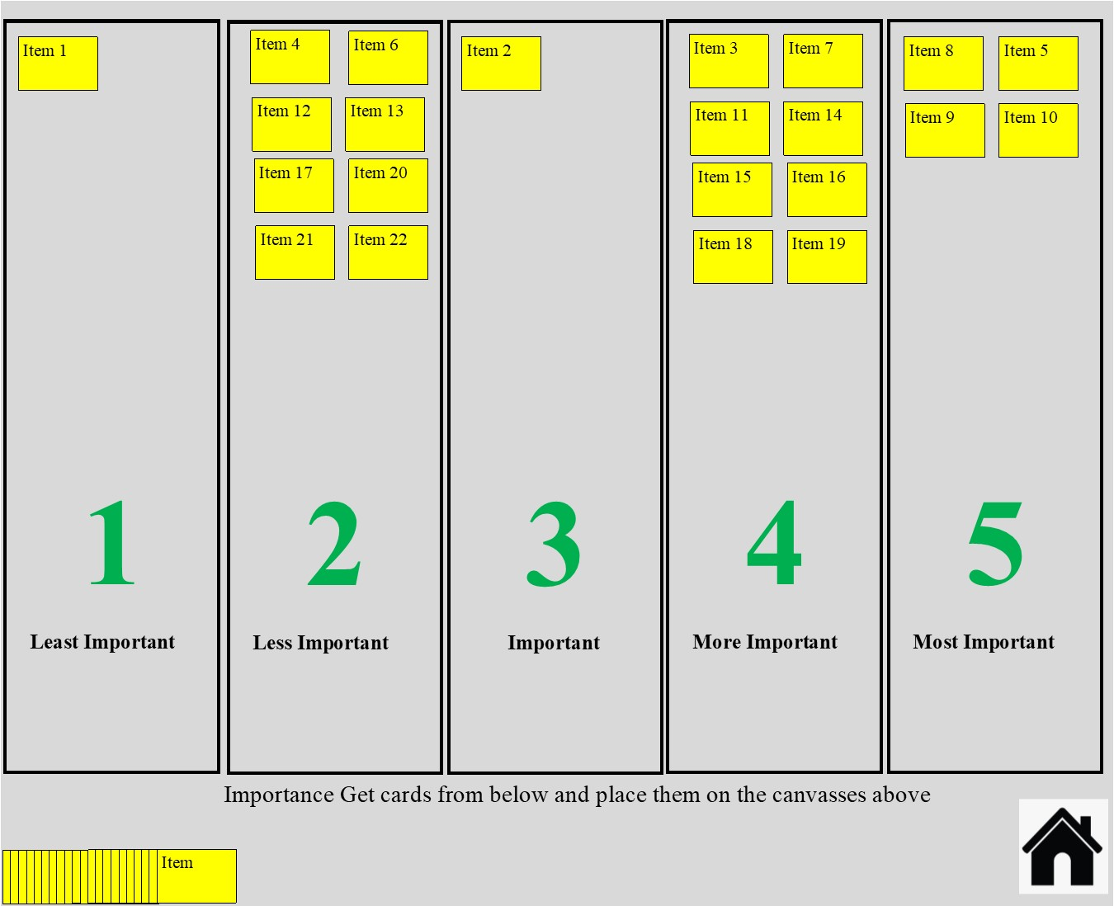
Figure 3: Moving cards from the deck to one of five vertical columns

Step 3: Moving cards from one column to another
If we think that we have placed a card into the wrong column, we can drag the card from one column to another column.
For example we can drag the card “item 22”(figure 4) from column 2 ‘less important’ (picture above) to column 5 “more important” (figure 5).

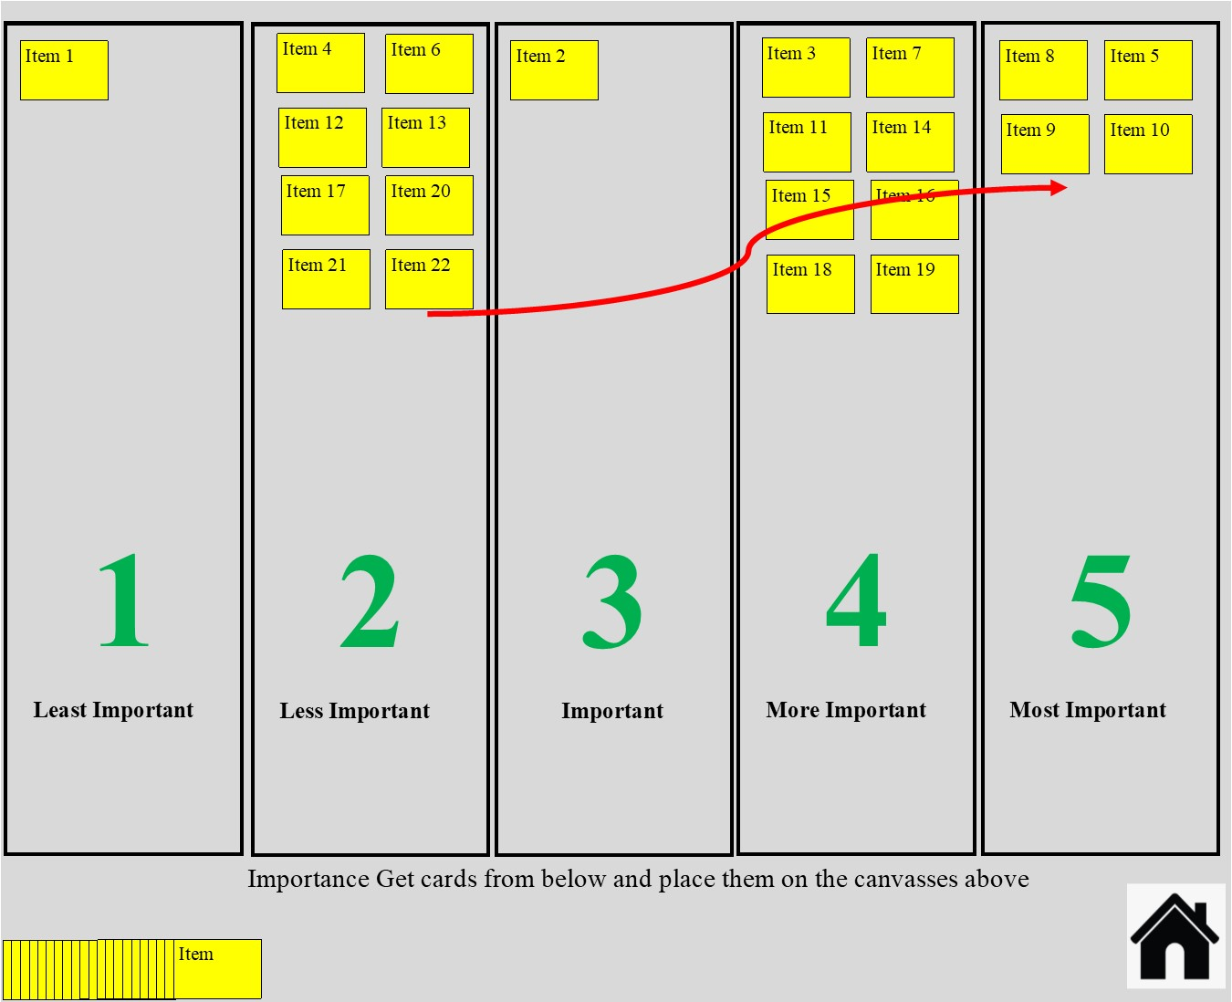
Figure 4: Moving statements between vertical columns

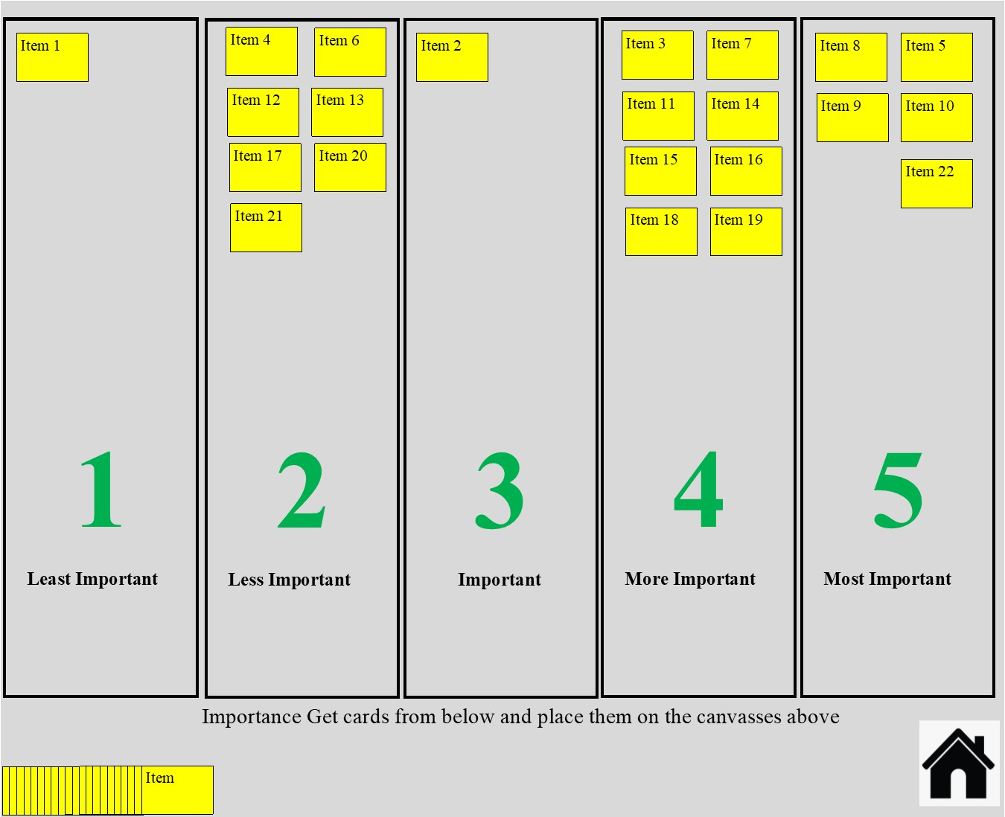
Figure 5: Moving statements between columns
Step 4: Ensuring that each column has equal number of cards
We need to ensure that equal number of cards are placed in each column. If the number of cards in one column exceeds the maximum number of cards that it can have, it will not be saved and these cards are placed back into the deck (at the bottom left corner where all cards are seen at the beginning).
For example, in figure 6 “item 78” exceeds beyond the capacity of column 4. If we have to place the card in this place, we don’t have any more space here; so we need to create space for column 4.
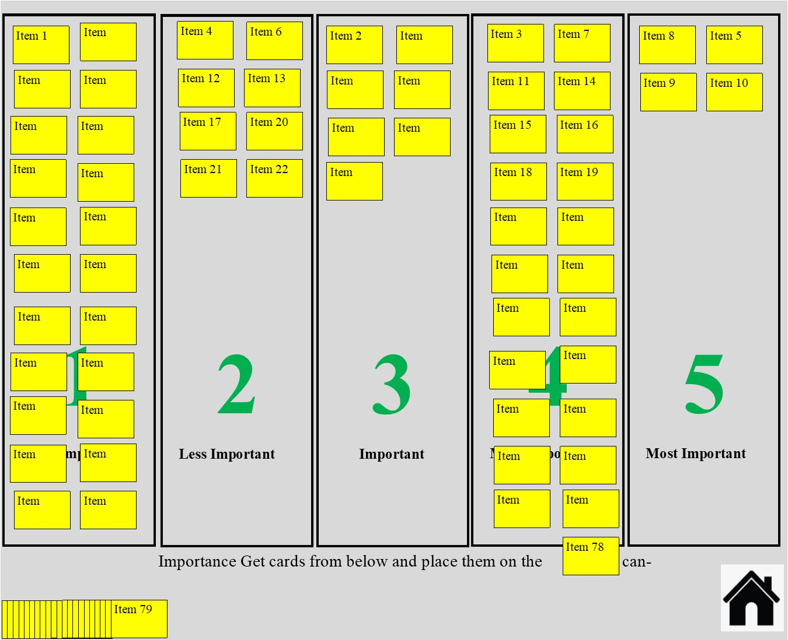
Figure 6: Managing excess cards in one column
For this, we need to remove a card from this column. We can do it by selecting a card (say for example “item 11”) which we think might not be suitable for this column and placing it back to the deck. The card “item 11” needs then to be organized into one of the four remaining columns before we can proceed further.
We need to continue till we complete placing all the cards from the deck into one of the five columns.
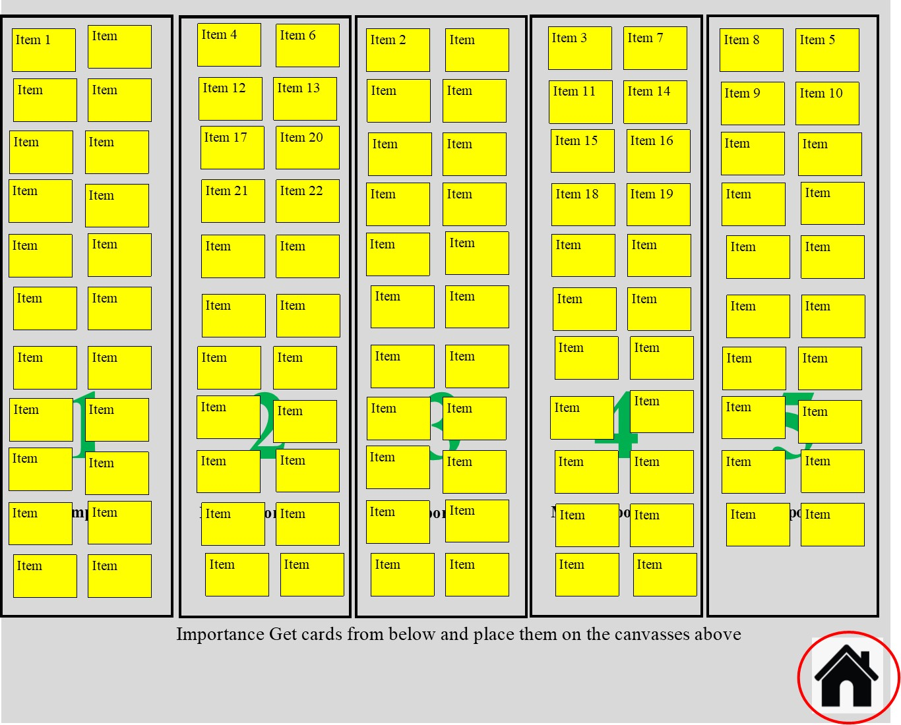
Figure 7: Prioritization task home screen after completion
We need to click the botton to save the task.
Task 2 Clustering
For this task, we need to group the statements, based on their similarity. We need to place the statements into if one group if we think they are related to each other. We can create as many groups as we would like. We can use the individual statement only once. After we complete arranging the statements into individual groups, we need to provide a suitable name for the individual group.
Step 5: Navigating to the clustering task
After completing the prioritization task, we proceed for the clustering task. For this we need to go back button at the top left corner of the computer screen (figure 8) to the “Ariadne” home page and click on clustering (figure 1).
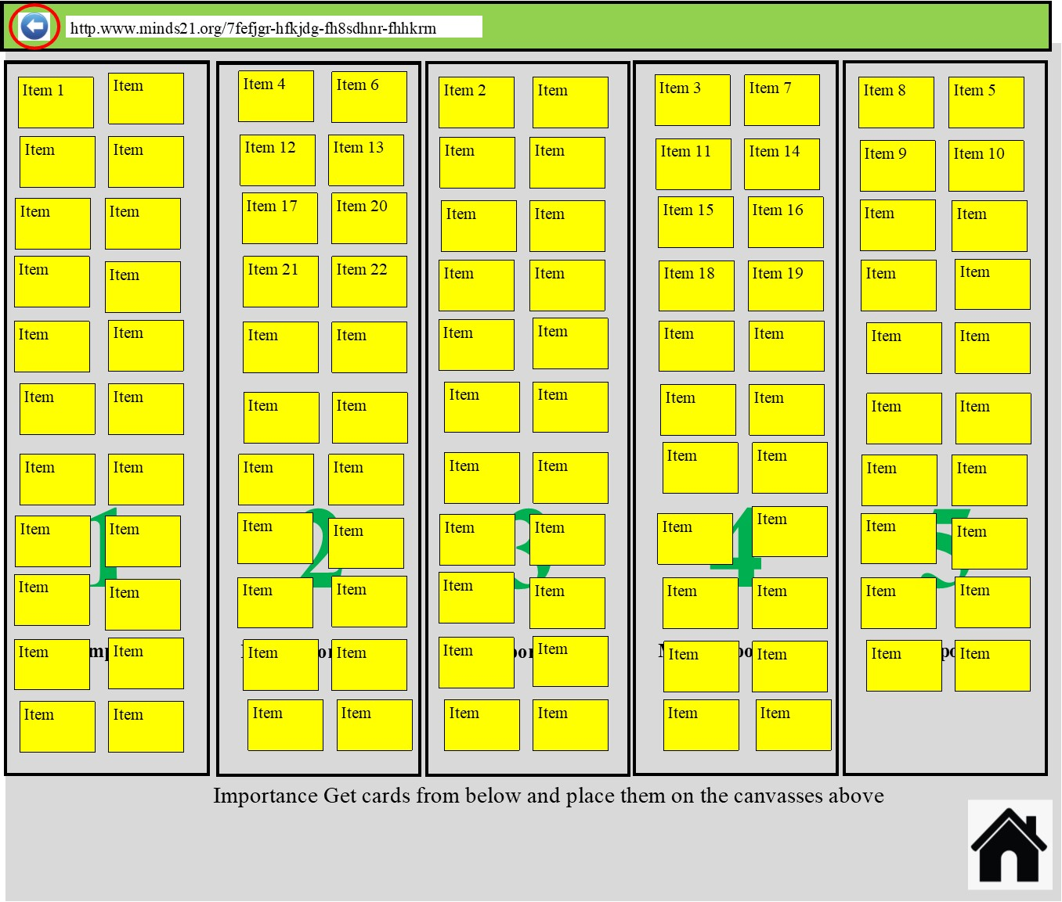
Figure 8: moving back to Ariadne home screen
Once we click the clustering task, the following screen appears in our computer.
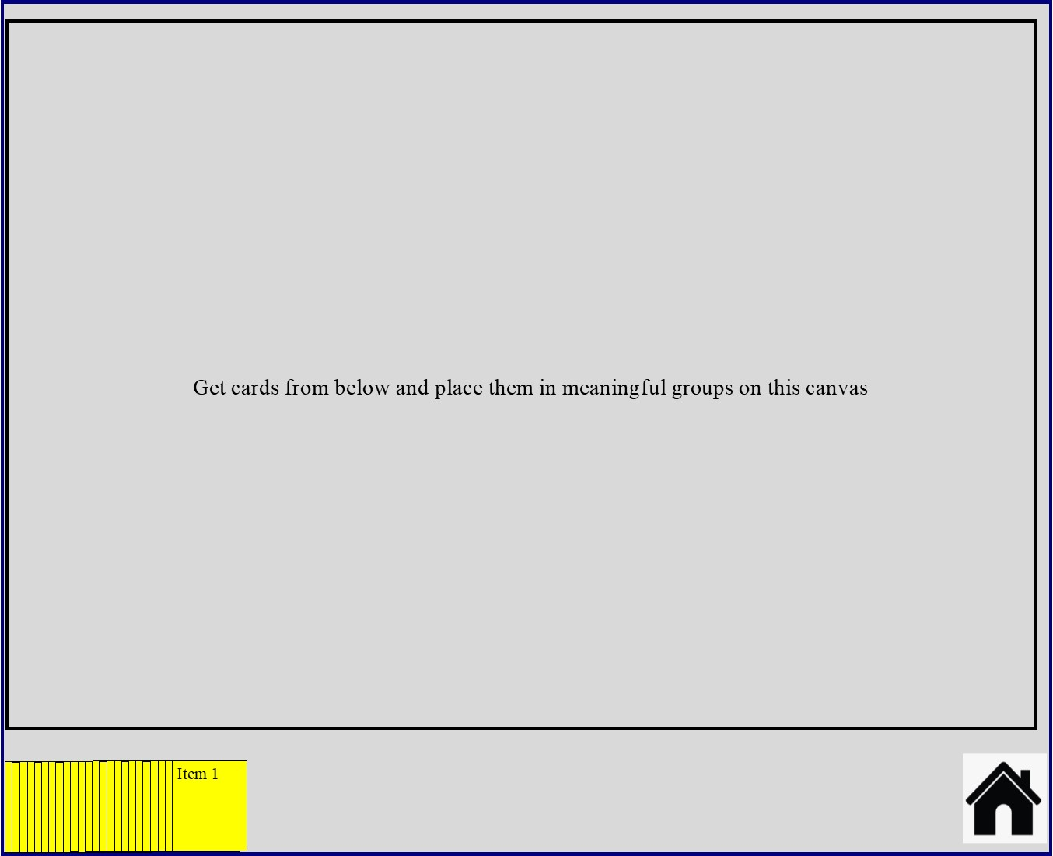
Figure 9: clustering task home page
Step 6: Putting cards into clusters
We can drag cards from the deck (right bottom corner of the screen) to the canvas above and place the cards into clusters. Here, we need to note that we can place the cards at any part of the upper canvas.
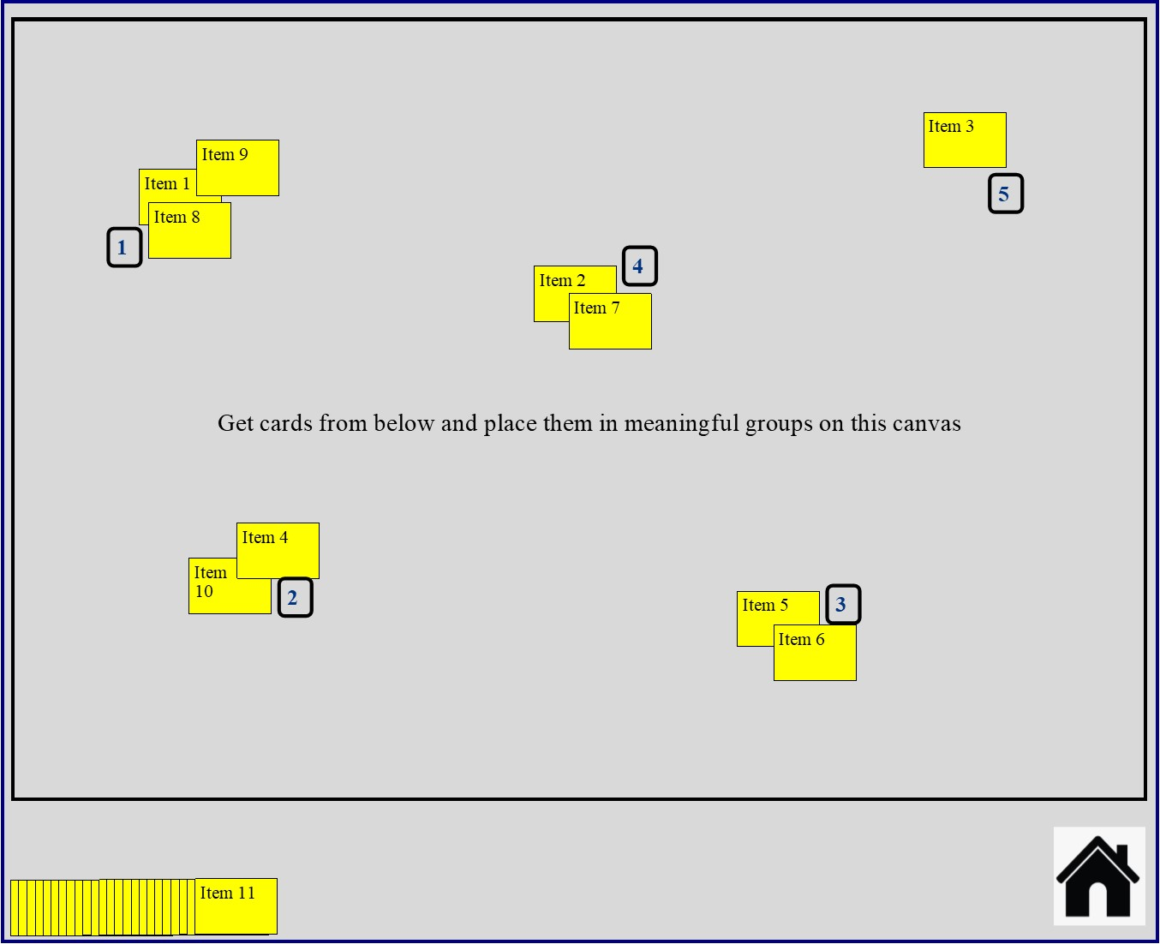
Figure 10: Moving the cards from the deck for clustering
In figure 10, we can see that the first ten cards have been moved from the deck and arranged into five clusters at different parts of the canvas. Ariadne automatically names the cluster as number. For example, the five clusters created in figure 10 have been named as 1-5.
We need to carry out this step till we complete all the cards from the deck.
Step 7 Renaming the clusters.
Once we complete the tasks, we need to provide a meaningful name to the cluster that can represent the statements in the cluster.
For naming the cluster, we need to click on the number in the cluster, and type in the name.
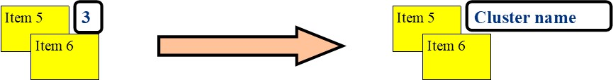
Figure 11: Renaming the clusters
For example, the group 3 has been renamed as “cluster name”

Step 8 Saving the clustering task
After all the cards have been arranged in clusters and we have named the individual clusters, we can click on the home bottom at the bottom right corner of the clustering home page (figure 8-10) to save our work.

